JAVA FOR BEGINNERS:

package com.company;  
  
public class Main {  
  
 public static void main(String[] args) {  
 // write your code here  
 System.*out*.println("Hello World");  
 }  
}

here public is access modifier

main 🡪 is the name of the function

Main 🡪 is the name of the class

Static here means no objects required

Void here means nothing will be returned / expected in return

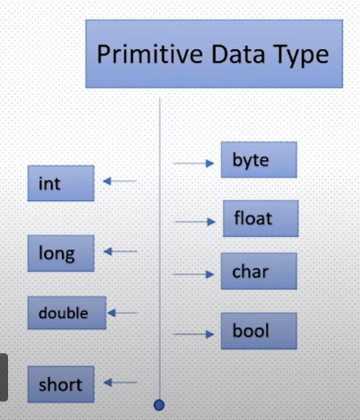“//” 🡪 used to write comments

Variables can contain alphabets, $, _, digits(cannot start with digits like 1arr is an invalid variable name)

Primitive data types

|  |  |
| --- | --- |
| byte | Value ranges from -128 to 127  Takes 1 byte  Default value is 0 |
| short | Value ranges from -(2)^16/2 to ((2^16)/2) -1  Takes 2 bytes  Default value is zero |
| int | Value ranges from –(2)^32/2 to ((2^32)/2)-1  Takes 4 bytes  Default value is zero |
| float | Takes 4 bytes  Default value is 0.0f |
| long | Ranges from –(2)^64/2 to ((2^64)/2)-1  Takes 8 bytes  Default value is zero |
| double | Takes 8 bytes  Default value is 0.0d |
| char | Value ranges from 0 to (2^16)-1  Takes 2 bytes (it supports Unicode)  Default value is \U0000 |
| bool | Value can be true or false  Default value is false  Size depends on JVM |

Java code to add 3 numbers

package com.company;  
  
public class Main {  
  
 public static void main(String[] args) {  
 // write your code here  
 int num1 = 6;  
 int num2 = 5;  
 int num3 = 4;  
 int sum = num1+num2+num3;  
 System.*out*.println(sum);  
 }  
}

here ln in println means new line

package com.company;  
  
public class Main {  
  
 public static void main(String[] args) {  
 System.*out*.print("the sum of the 3 numbers is: ");  
 int num1 = 6;  
 int num2 = 5;  
 int num3 = 4;  
 int sum = num1+num2+num3;  
 System.*out*.println(sum);  
 }  
}

a constant value which can be assigned to the variable is called as a literal

|  |  |
| --- | --- |
| 101 | Integer literal |
| 10.1f or 10.1F | Float literal |
| 10.1 or 10.1D or 10.1d | Double literal (default type for decimals) |
| ‘A’ | Character literal |
| true | Boolean literal |
| “ABHI” | String literal |

package com.company;  
  
public class Main {  
  
 public static void main(String[] args) {  
 System.*out*.println("lets us learn about literals: ");  
 long number = 24L;  
 long number2 = 25l;  
 char letter = 'A';  
 float decimal = 23.5f;  
 double num = 2.3;  
 short short_num = 234;  
 String word = "Abhi";  
 System.*out*.println(number);  
 System.*out*.println(number2);  
 System.*out*.println(letter);  
 System.*out*.println(decimal);  
 System.*out*.println(num);  
 System.*out*.println(short_num);  
 System.*out*.println(word);  
 }  
}

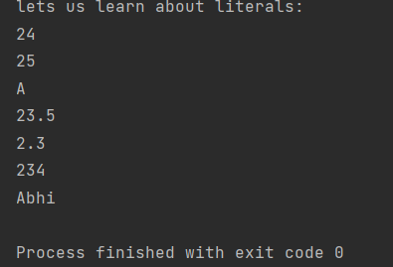

TIP:

Remember to use the data types correctly; for example we cannot store a big number in short 🡪 it will give us an error

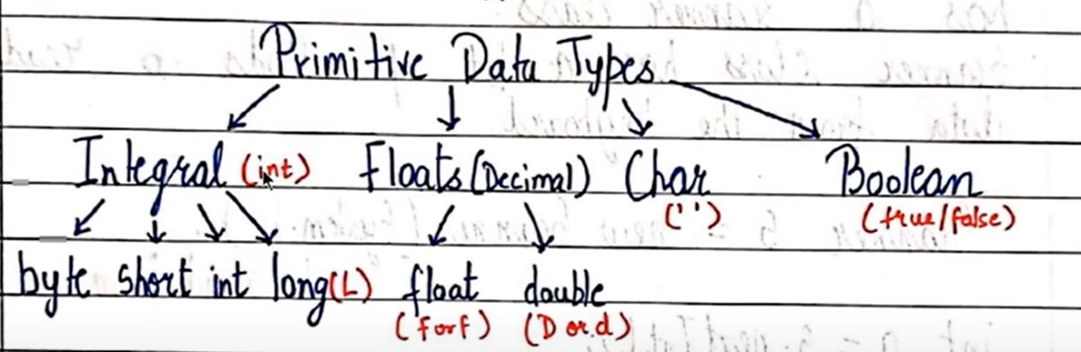

Instead of writing “System.out.println()” everytime just write “sout” and press enter it will automatically get printed on the screen.

To take inputs from the user we have to import the class ; so write this statement “import java.util.Scanner;”

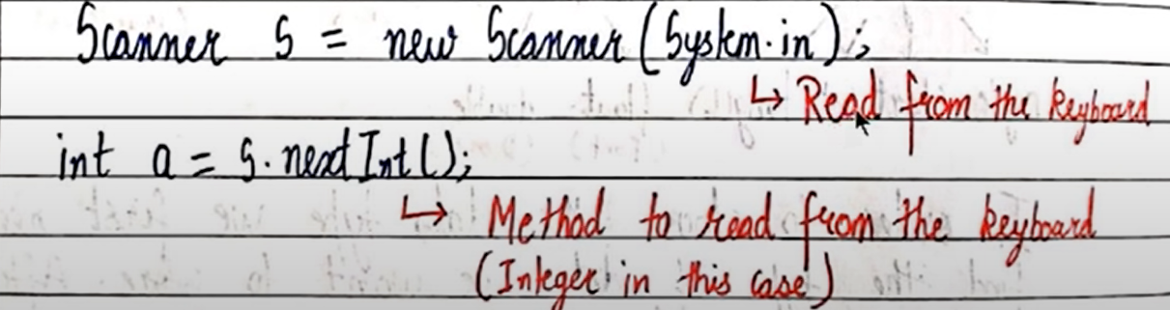

package com.company;  
import java.util.Scanner;  
  
public class Main {  
  
 public static void main(String[] args) {  
 Scanner sc = new Scanner(System.*in*);  
 System.*out*.print("enter number 1: ");  
 int a = sc.nextInt();  
 System.*out*.print("enter number 2: ");  
 int b = sc.nextInt();  
 int sum = a+b;  
 System.*out*.print("sum of the 2 numbers is: " + sum);  
 }  
}

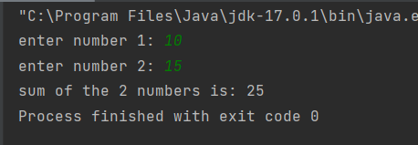

If we have to add 2 floating numbers then instead of writing **int a = sc.nextInt()** we will write **float a = sc.nextFloat()**

Now if we want to check whether the input number has been successfully stored in our variable, we will write the following piece of code

int a = sc.nextInt();  
System.*out*.print(sc.hasNextInt());

it will give us true if the variable a holds the input value and false if it does not hold it or the user has given different type of a data type than int

package com.company;  
import java.util.Scanner;  
  
public class Main {  
  
 public static void main(String[] args) {  
 System.*out*.println("enter the word ");  
 Scanner sc = new Scanner(System.*in*);  
 String str = sc.next();  
 System.*out*.println(str);  
 Scanner sc2 = new Scanner(System.*in*);  
 String str2 = sc2.nextLine();  
 System.*out*.println(str2);  
 }  
}

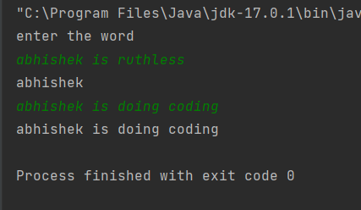

Here **next** will just store the letters till the first blank space whereas **nextLine** will store the whole string instead of just one word.

Code to calculate percentage:

package com.company;  
import java.util.Scanner;  
  
public class Main {  
  
 public static void main(String[] args) {  
 Scanner sc = new Scanner(System.*in*);  
 System.*out*.println("enter the name of the student: ");  
 String name = sc.nextLine();  
 System.*out*.println("enter Physics marks: ");  
 float Phy_marks = sc.nextShort();  
 System.*out*.println("enter Chemistry marks: ");  
 float Chem_marks = sc.nextShort();  
 System.*out*.println("enter Maths marks:");  
 float Maths_marks = sc.nextShort();  
 float total = (Phy_marks)+(Chem_marks)+(Maths_marks);  
 float percent = (total*100)/300;  
 System.*out*.println(name +"'s percentage is: ");  
 System.*out*.println(percent);  
 }  
}

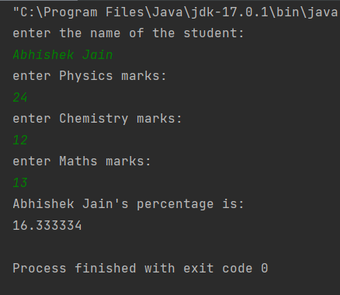

If we want the ans in float store all the inputs related to it in float

Determine whether the number which is given by the user is an integer or not

package com.company;  
import java.util.Scanner;  
  
public class Main {  
  
 public static void main(String[] args) {  
  
 System.*out*.println("enter a number");  
 Scanner sc = new Scanner(System.*in*);  
 System.*out*.println(sc.hasNextInt());  
  
 }  
}

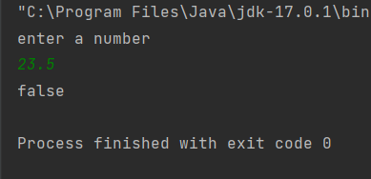

7 + 11 = 18

**Here 7 and 11 are operands**

**+ is operator**

**18 is result**

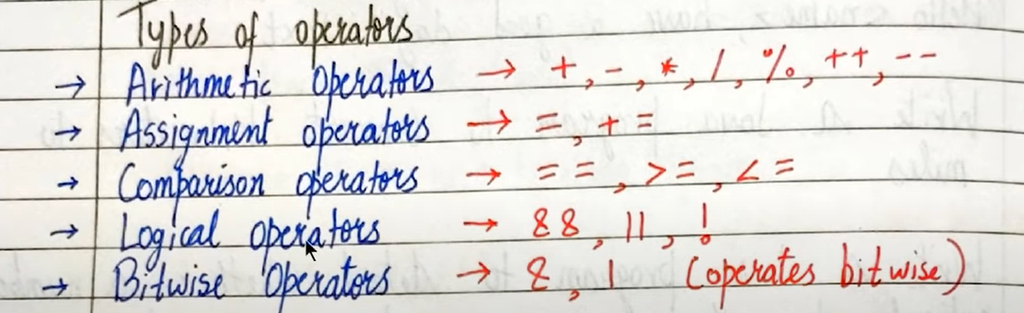

Arithmetic operators cannot work on Booleans

% operator can work on float and doubles

“&&” – used for ***and*** (logical and)

“||” – used for ***or*** (logical or)

“=” is an assignment operator whereas “==” is a comparison operator

**Precedence** means order; it tells us which expression will be evaluated first

**Associativity** means right to left or left to right

Ex: 6*4 – 2 🡺 24-2 = 22 (precedence)

Ex: 60/5 – 2*5 🡺 12 – 2*5 = 12-10 = 2 (associativity) {since * and / have same precedence}

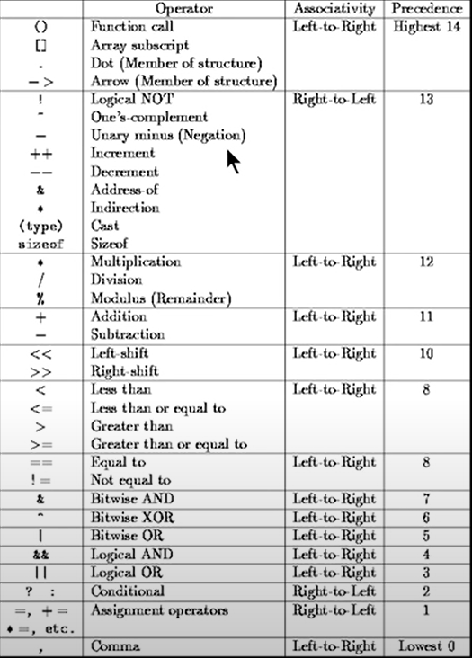

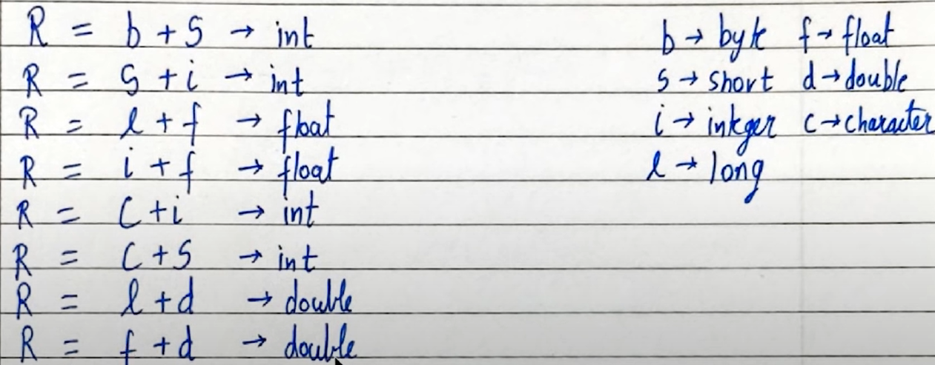

Difference between ++a and a++

package com.company;  
import java.util.Scanner;  
  
public class Main {  
  
 public static void main(String[] args) {  
 int a = 12;  
 System.*out*.println(a++);  
 System.*out*.println(a);  
 System.*out*.println(++a);  
 System.*out*.println(a);  
 }  
}

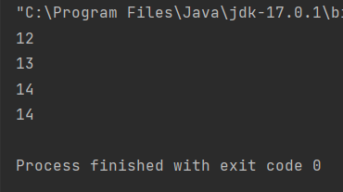

Here **a++** means first a will be printed and then it will get incremented

Here **++a** means first a will be incremented and then it will be printed

(**++a** here ++ pehle and then a and in **a++** a pehle and ++ )

**Int c = ++j** 🡪 *here first j is incremented and then the value is stored in c*

**Int c = j++** 🡪 *here first c is assigned j and then j is incremented*

package com.company;  
import java.util.Scanner;  
  
public class Main {  
  
 public static void main(String[] args) {  
 int j = 12;  
 int a = j++;  
 System.*out*.println(a);  
 int b = ++j;  
 System.*out*.println(b);  
  
 }  
}

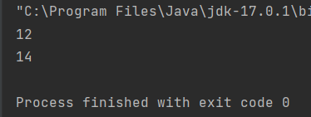

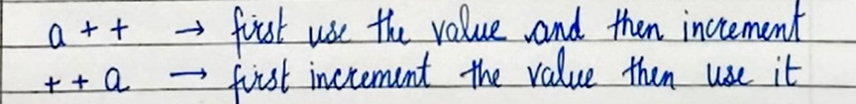

Increment operators on char

package com.company;  
import java.util.Scanner;  
  
public class Main {  
  
 public static void main(String[] args) {  
 char a = 'C';  
 System.*out*.println(++a);  
 }  
}

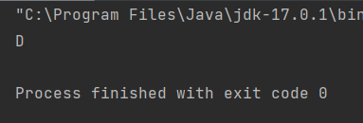

typecasting (converting one data type to another)

package com.company;  
import java.util.Scanner;  
  
public class Main {  
  
 public static void main(String[] args) {  
 char grade = 'B';  
 grade = (char)(grade + 8);  
 System.*out*.println(grade);  
 grade = (char)(grade - 8);  
 System.*out*.println(grade);  
 }  
}

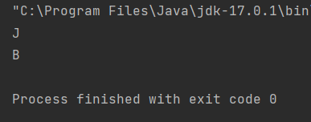

String is a class in Java but we can use it as a datatype

package com.company;  
import java.util.Scanner;  
  
public class Main {  
  
 public static void main(String[] args) {  
 String name = new String("Abhi");  
 String a = "abhi";  
 System.*out*.println(a);  
 System.*out*.println(name);  
 }  
}

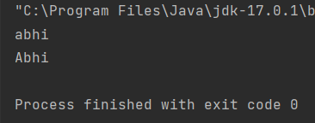

Strings are immutable and cannot be changed that means it we want to make **abhi** to **Abhi** we cannot do it to the same object; but we can make a copy of it and then make the required changes

package com.company;  
import java.util.Scanner;  
  
public class Main {  
  
 public static void main(String[] args) {  
 //String name = new String("Abhi");  
 String name = "abhi";  
 System.*out*.print("My name is: ");  
 System.*out*.println(name);  
 int age = 21;  
 float months = .9123f;  
 System.*out*.printf("%s is %d and %.2f years old.",name, age, months);  
 // here %.2f means 2 digits after decimal   
 }  
}

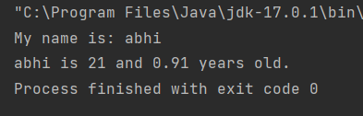

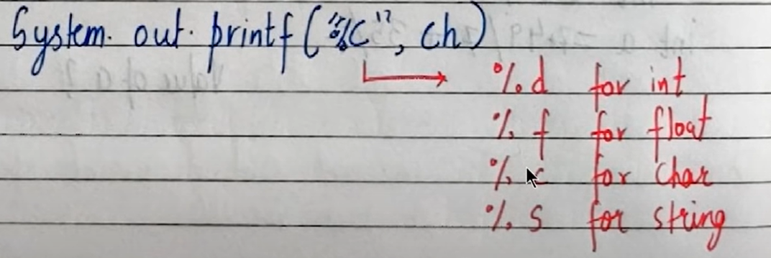These %d, %s, %f are called ***format specifier.***

System.out.printf is the same as System.out.format

%8.2f means 8 spaces including the whole number and only 2 digits after decimal

**String operations:**

Name = Abhishek

Name2 = banana

|  |  |
| --- | --- |
| Name.length() | Will return the length of the variable “name” |
| Name.toLowerCase() | Will convert all characters of the string to lower case |
| Name.toUpperCase() | Will convert all characters of the string to upper case |
| Name.trim() | Will remove blank spaces after and before the string |
| Name.substring(x) | Will give us the string starting from index 3 of name till the end |
| Name.substring(x,y) | Will give us the substring staring form index x till index y  **NOTE:** *x is included but y is not* |
| Name.replace(x,y) | Here all x in name will be replaced by y  Here we can pass characters as well as string to replace |
| Name.startsWith(x) | Here it will return true or false based on whether the string starts with x  Here x can be a character or a string |
| Name.endsWith(x) | Here it will return true or false based on whether the string ends with x  Here x can be a character or a string |
| Name.charAt(x) | Value at index x will be returned |
| Name.indexOf(x) | Returns index of first recurrence of x  Here x can be a character or a string  Will return -1 if it is not present |
| Name.indexOf(x,y) | Start searching for x from index y onwards till the end |
| Name.lastIndexOf(x) | Will return the index of x. here it will start searching from the last |
| Name.lastIndexOf(x,y) | Will return the index of x. here the string it will take into consideration will be from 0 to y (y is included) and then it will start searching from the last |
| Name.equals(x) | Will return true or false if x is equal to value in the variable ‘name’ |
| Name.equalsIgnoreCase(x) | Will return true or false if x is equal to name (here lower case or upper case will not be taken into consideration) |

package com.company;  
import java.util.Locale;  
import java.util.Scanner;  
  
public class Main {  
  
 public static void main(String[] args) {  
 String name = "Abhishek";  
 int value = name.length();  
 System.*out*.println(value);  
  
 String lower = name.toLowerCase();  
 System.*out*.println(lower);  
  
 String upper = name.toUpperCase();  
 System.*out*.println(upper);  
  
 String nonTrimmedString = " Abhishek ";  
 System.*out*.println(nonTrimmedString.trim());// removes spaces from front and back//  
 // another way of using the trim function//  
 String trimmedString = nonTrimmedString.trim();  
 System.*out*.println(trimmedString);  
  
 System.*out*.println(name.substring(3)); // will give us the string starting from index 3 till the end  
 System.*out*.println(name.substring(3,6)); // 3 is included but 6 is not  
 System.*out*.println(name.substring(3,value));  
  
 System.*out*.println(name.replace('h','q')); // all h in name will be replaced by q  
 System.*out*.println(name.replace("shek","shake"));  
 System.*out*.println(name.replace("shek","s"));  
  
 String name2 = "banana";  
  
 System.*out*.println(name2.replace("an","at"));  
  
 System.*out*.println(name.startsWith("Abhi")); // will return true  
 System.*out*.println(name.endsWith("iek")); // will return false  
  
 System.*out*.println(name.charAt(2));// index 2 value will be returned  
 System.*out*.println(name2.indexOf("an")); // returns index of only the first recurrence  
 System.*out*.println(name2.indexOf("an",3)); // start searching "an" from index 3 till the end  
 System.*out*.println(name.indexOf("sed")); // will return -1 since "sed" is not present in name  
  
 System.*out*.println(name2.lastIndexOf("n"));  
 System.*out*.println(name2.lastIndexOf("an",2)); //"an" will be searched from "ban" in banana  
 System.*out*.println(name2.lastIndexOf("an",3)); // "an" will be searched from "bana"  
 // here for "bana" an will be checked for index 3  
  
 System.*out*.println(name.equals("abhishEk")); // checks the string with variable value  
 System.*out*.println(name.equalsIgnoreCase("abhisHEK")); // will ignore uppercase and lowercase letters and will then compare  
  
 // Escape sequence characters  
 System.*out*.println("I am an escape sequence character \"double character\"");  
 System.*out*.println("It\'s his\\her choice!");  
  
  
 }  
}

Output:

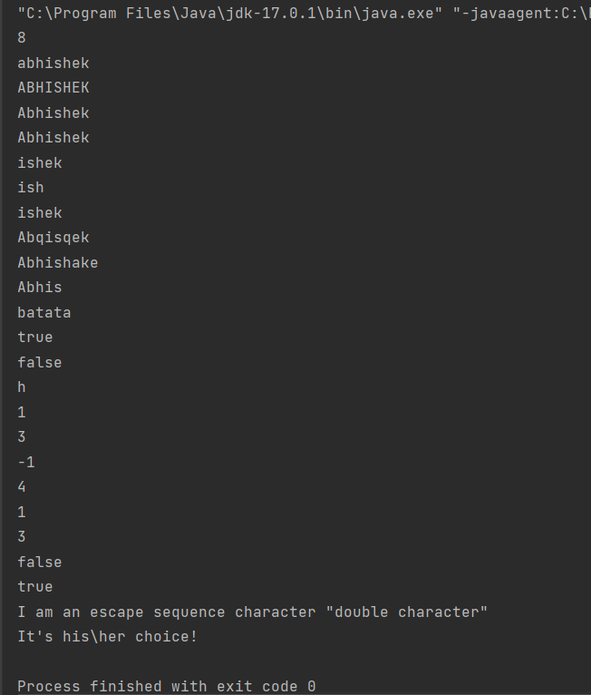

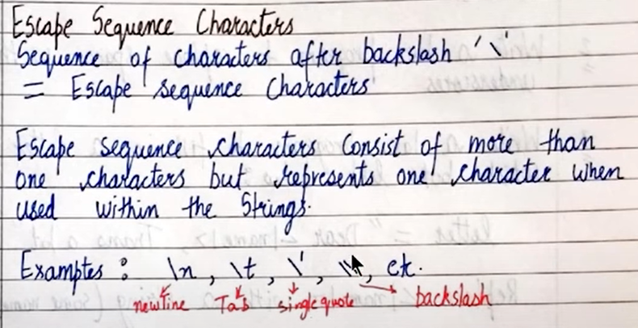**Escape Sequence characters**

package com.company;  
import java.util.Locale;  
import java.util.Scanner;  
  
public class Main {  
  
 public static void main(String[] args) {  
  
 // Escape sequence characters  
 System.*out*.println("I am an escape sequence character \"double character\"");  
 System.*out*.println("It\'s his\\her choice!");  
   
 }  
}

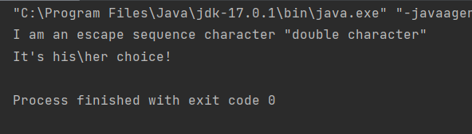

package com.company;  
import java.util.Locale;  
import java.util.Scanner;  
  
public class Main {  
  
 public static void main(String[] args) {  
  
 String letter = "Thank you name";  
 letter.replace("name","abhi");  
 System.*out*.println(letter);  
 letter = letter.replace("name","abhi");  
 System.*out*.println(letter);  
  
 }  
}

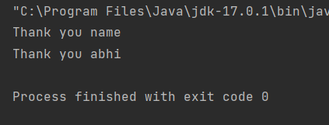

Write a program to detect double and triple spaces

package com.company;  
import java.util.Locale;  
import java.util.Scanner;  
  
public class Main {  
  
 public static void main(String[] args) {  
  
 String line = "How are you?";  
 System.*out*.println(line.indexOf(" ")!=-1); // true if it contains double spaces  
 System.*out*.println(line.indexOf(" ")!=-1); // true if it contains triple spaces  
  
 }  
}

conditionals:

relational operators: >, <, <=, >=, !=, ==

package com.company;  
import java.util.Locale;  
import java.util.Scanner;  
  
public class Main {  
  
 public static void main(String[] args) {  
  
 int age = 16;  
 if (age >= 18){  
 System.*out*.println("You are an adult");  
 }  
 else{  
 System.*out*.println("You are still a kid");  
 }  
 }  
}

another way of writing the same code

package com.company;  
import java.util.Locale;  
import java.util.Scanner;  
  
public class Main {  
  
 public static void main(String[] args) {  
  
 int age = 16;  
 boolean cond = (age>=18);  
 if (cond){  
 System.*out*.println("You are an adult");  
 }  
 else{  
 System.*out*.println("You are still a kid");  
 }  
 }  
}

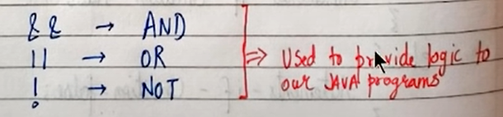Logical operators

package com.company;  
import java.util.Locale;  
import java.util.Scanner;  
  
public class Main {  
  
 public static void main(String[] args) {  
  
 int age = 16;  
 if (age>=18){  
 System.*out*.println("You are an adult");  
 }  
 else if (age >= 15){  
 System.*out*.println("You are a teenager");  
 }  
 else{  
 System.*out*.println("You are still a kid");  
 }  
 }  
}

switch case control instruction:

It is used when we have to make a choice between number of alternatives for a given variable

package com.company;  
import java.util.Locale;  
import java.util.Scanner;  
  
public class Main {  
  
 public static void main(String[] args) {  
 int age;  
 Scanner sc = new Scanner(System.*in*);  
 System.*out*.println("enter your age: ");  
 age = sc.nextInt();  
  
 switch (age){  
 case 2:  
 System.*out*.println("you are a baby");  
 break;  
 case 10:  
 System.*out*.println("you are in school");  
 break;  
 default:  
 System.*out*.println("enjoy your life");  
 }  
 }  
}

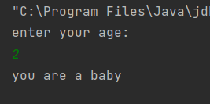

break here means come out of the switch loop

if we do not use break statements all the case statements (after the one which is matched or all if none of them is matched) as well as default will be executed.

Here value after case (here age) can be int, char, string

A switch can occur within another but in practice it is rarely done

Another way of writing the same code(***using enhanced switch statement)***

Hover to the switch statement and click on enhances switch statement.

package com.company;  
import java.util.Locale;  
import java.util.Scanner;  
  
public class Main {  
  
 public static void main(String[] args) {  
 int age;  
 Scanner sc = new Scanner(System.*in*);  
 System.*out*.println("enter your age: ");  
 age = sc.nextInt();  
  
 switch (age) {  
 case 2 -> System.*out*.println("you are a baby");  
 case 10 -> System.*out*.println("you are in school");  
 default -> System.*out*.println("enjoy your life");  
 }  
 }  
}

one main feature of writing it in this way is it does not require break statement

another code using if and else:

package com.company;  
import java.util.Locale;  
import java.util.Scanner;  
  
public class Main {  
  
 public static void main(String[] args) {  
 byte m1, m2 ,m3;  
 Scanner sc = new Scanner(System.*in*);  
 System.*out*.println("enter your Physics marks");  
 m1 = sc.nextByte();  
 System.*out*.println("enter your chemistry marks");  
 m2 = sc.nextByte();  
 System.*out*.println("enter your maths marks");  
 m3 = sc.nextByte();  
 float total = m1+m2+m3;  
 float percent = (total/300)*100;  
 if (m1>=40 && m2>=40 && m3>=40 && percent>=36){  
 System.*out*.println("You have passed");  
 }  
 else{  
 System.*out*.println("You have failed");  
 }  
  
 }  
}

Using loops:

1. While loop:

package com.company;  
import java.util.Locale;  
import java.util.Scanner;  
  
public class Main {  
  
 public static void main(String[] args) {  
 int i = 1;  
 while (i<=3){  
 System.*out*.println(i);  
 i++;  
 }  
  
 }  
}

1. Do while loop:

It is similar to while loop except it will get executed at least once

package com.company;  
import java.util.Locale;  
import java.util.Scanner;  
  
public class Main {  
  
 public static void main(String[] args) {  
 int i = 10;  
 do {  
 System.*out*.println(i);  
 i++;  
 }while (i <= 5);  
  
 }  
}

1. For loop:

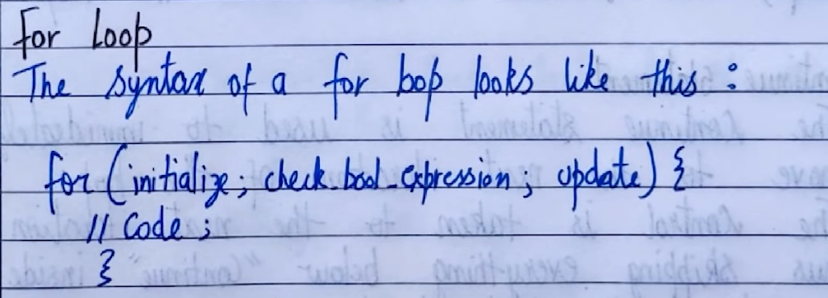package com.company;  
import java.util.Locale;  
import java.util.Scanner;  
  
public class Main {  
  
 public static void main(String[] args) {  
 for (int i=0;i<10;i++){  
 System.*out*.println(i);  
 }  
  
 }  
}

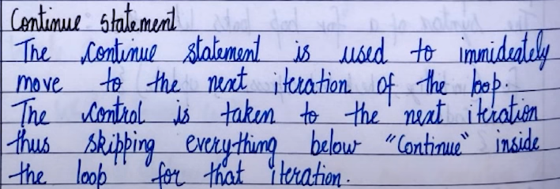break and continue statements:

package com.company;  
import java.util.Locale;  
import java.util.Scanner;  
  
public class Main {  
  
 public static void main(String[] args) {  
 for (int i=0;i<10;i++){  
 if (i == 6){  
 System.*out*.println("using continue in the loop");  
 continue; // line after this will not be executed the control will directly again shift to the for loop  
 }  
 System.*out*.println(i);  
 }  
  
 }  
}

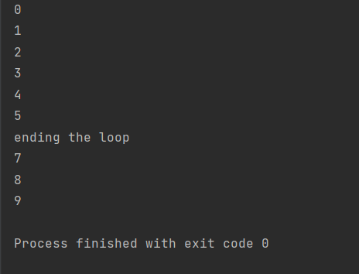

Code to draw a pattern

package com.company;  
import java.util.Locale;  
import java.util.Scanner;  
  
public class Main {  
  
 public static void main(String[] args) {  
 for (int i = 5; i!=0; i--){ //column  
 for (int j = 0; j<i; j++){ // row  
 System.*out*.print("*");  
 }  
 System.*out*.print("\n");  
  
 }  
  
 }  
}

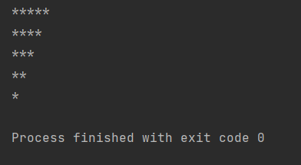

Sum of n numbers using while loop:

package com.company;  
import java.util.Locale;  
import java.util.Scanner;  
  
public class Main {  
  
 public static void main(String[] args) {  
 int n = 10;  
 int i = 1;  
 int sum = 0;  
 while (i!=10){  
 sum+=i;  
 i++;  
 }  
 System.*out*.printf("sum of %d numbers is: %d",n,sum);  
  
 }  
}

creating a multiplication table

package com.company;  
import java.util.Locale;  
import java.util.Scanner;  
  
public class Main {  
  
 public static void main(String[] args) {  
 int n = 10;  
 int i = 1;  
 while (i!=10){  
 int ans = n*i;  
 System.*out*.printf("%d x %d = %d\n",n,i,ans);  
 i++;  
 }  
 }  
}

now printing the same multiplication table but in reverse order

package com.company;  
import java.util.Locale;  
import java.util.Scanner;  
  
public class Main {  
  
 public static void main(String[] args) {  
 int n = 10;  
 int i = 10;  
 while (i!=0){  
 int ans = n*i;  
 System.*out*.printf("%d x %d = %d\n",n,i,ans);  
 i--;  
 }  
  
  
 }  
}

Code to find factorial of a number

package com.company;  
import java.util.Locale;  
import java.util.Scanner;  
  
public class Main {  
  
 public static void main(String[] args) {  
 int n = 4;  
 int fact = 1;  
 for (int i = 1;i!=n+1;i++){  
 fact = fact*i;  
 }  
 System.*out*.printf("the factorial of %d is: %d",n,fact);  
  
  
 }  
}

Arrays:

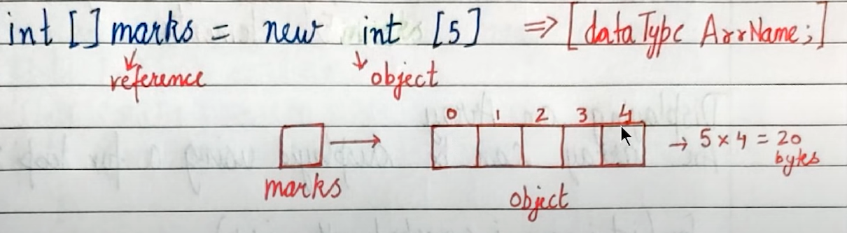Array is a collection of similar type of data



Accessing elements in an array is faster

20 bytes of memory will be allocated since size of int is 4 and we need 5 such int

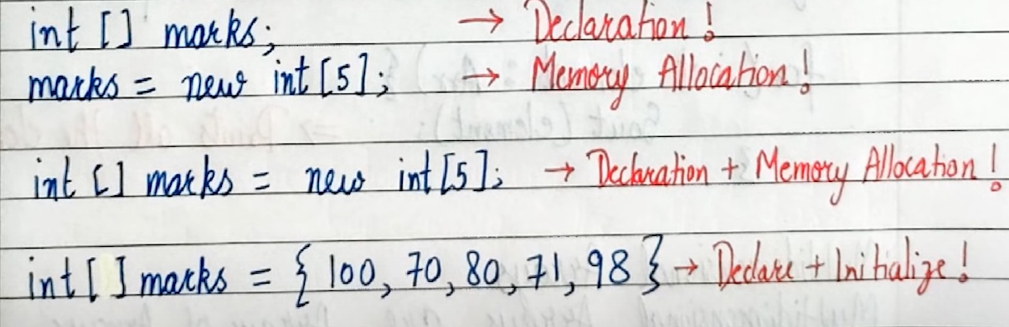3 ways to declare or initialize an array

package com.company;  
import java.util.Locale;  
import java.util.Scanner;  
  
public class Main {  
  
 public static void main(String[] args) {  
 int [] marks = new int[5];  
 marks[0] = 10;  
 marks[1] = 20;  
 marks[2] = 30;  
 marks[3] = 40;  
 marks[4] = 50;  
 marks[4] = 60; // we can overwrite in an array  
 //marks[5] = 70; // this will throw us an error since length if array is 5 and we are accessing 6 th element  
 System.*out*.println(marks[4]);  
  
  
 }  
}

Array traversal/ Displaying an array

package com.company;  
import java.util.Locale;  
import java.util.Scanner;  
  
public class Main {  
  
 public static void main(String[] args) {  
 float [] marks = {12.5f,14.3f,16.6f,15.3f,11.7f};  
 System.*out*.println(marks[0]);  
 System.*out*.println(marks.length); // gives length of array  
 System.*out*.println("displaying an array: ");  
 for (int i = 0; i<marks.length; i++)

{  
 System.*out*.println(marks[i]);  
 }  
 }  
}

displaying elements of an array in reverse order

package com.company;  
import java.util.Locale;  
import java.util.Scanner;  
  
public class Main {  
  
 public static void main(String[] args) {  
 float [] marks = {12.5f,14.3f,16.6f,15.3f,11.7f};  
 System.*out*.println(marks[0]);  
 System.*out*.println(marks.length); // gives length of array  
 System.*out*.println("displaying an array in reverse order: ");  
 for (int i = (marks.length)-1; i!=-1; i--)  
 {  
 System.*out*.println(marks[i]);  
 }  
 }  
}

another way of array traversing (using for each loop):

package com.company;  
import java.util.Locale;  
import java.util.Scanner;  
  
public class Main {  
  
 public static void main(String[] args) {  
 float [] marks = {12.5f,14.3f,16.6f,15.3f,11.7f};  
 for (float e : marks) // e is for element  
 {  
 System.*out*.println(e);  
 }  
 }  
}

**Multidimensional arrays:**

Each element of a multidimensional array is an array in itself

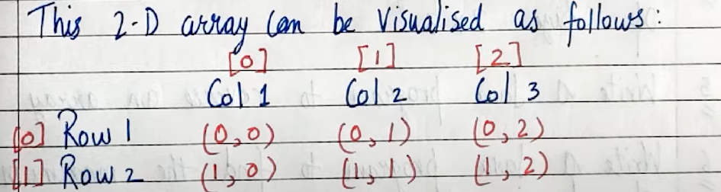Creating a 2D array

package com.company;  
import java.util.Locale;  
import java.util.Scanner;  
  
public class Main {  
  
 public static void main(String[] args) {  
 int [][] flats; // 2D array  
 flats = new int [2][3]; // it is basically 2 floors with 3 flats on each floor  
 // 2 will be size of flats(array) and 3 will be the size of array of each element of flats  
 flats[0][0] = 101;  
 flats[0][1] = 102;  
 flats[0][2] = 103;  
 flats[1][0] = 201;  
 flats[1][1] = 202;  
 flats[1][2] = 203;  
 System.*out*.println("printing all elements of a 2D array: ");  
 for (int i = 0 ; i<flats.length ; i++){  
 for (int j = 0 ; j< flats[i].length; j++ ){  
 System.*out*.println(flats[i][j]);  
 }  
 }  
 }  
}

some codes on array:

1. Code to calculate sum of all elements in an array:

package com.company;  
import java.util.Locale;  
import java.util.Scanner;  
  
public class Main {  
  
 public static void main(String[] args) {  
 float[] marks = {12.5f, 13.5f, 12.4f, 13.6f, 14.0f};  
 float sum = 0;  
 for (int i = 0; i < marks.length; i++) {  
 sum += marks[i];  
 }  
 System.*out*.printf("Sum of the array is: %f", sum);  
 }  
}

1. Code to find whether an element is present in an array or not

package com.company;  
import java.util.Locale;  
import java.util.Scanner;  
  
public class Main {  
  
 public static void main(String[] args) {  
 float[] marks = {12.5f, 13.5f, 12.4f, 13.6f, 14.0f};  
 int num = 14;  
 boolean flag = false;  
 for (int i = 0; i < marks.length; i++) {  
 if (marks[i] == num){  
 System.*out*.println("the given number is there in the array");  
 flag = true;  
 break;  
 }  
 }  
 if (flag == false){  
 System.*out*.println("the given element is not present in array");  
 }  
 }  
}

1. Java program to find max element in an array

package com.company;  
public class Main {  
  
 public static void main(String[] args) {  
 float[] marks = {12.5f, 13.5f, 12.4f, 13.6f, 14.0f};  
 float max = marks[0];  
 for (int i = 0; i < marks.length; i++) {  
 if (marks[i] > max){  
 max = marks[i];  
 }  
 }  
 System.*out*.printf("max element in the array is: %f",max);  
 }  
}

1. Java code to add 2 matrix of size 2x3

package com.company;  
import java.util.Locale;  
import java.util.Scanner;  
  
public class Main {  
  
 public static void main(String[] args) {  
 int[][] mat1 = {{1,2,3},{4,5,6}};  
 int[][] mat2 = {{1,2,3},{4,5,6}};  
 int[][] ans = {{0,0,0},{0,0,0}};  
 for(int i = 0; i<mat1.length; i++){  
 for(int j = 0; j<mat2[i].length; j++){  
 ans[i][j] = mat1[i][j] + mat2[i][j];  
 }  
 }  
 for (int i = 0; i<ans.length; i++){  
 for (int j = 0; j<ans[i].length; j++){  
 System.*out*.print(ans[i][j]);  
 System.*out*.print(" ");  
 }  
 System.*out*.println("");  
 }  
  
 }  
}

1. Java code to check if an array is sorted or not

package com.company;  
import java.util.Locale;  
import java.util.Scanner;  
  
public class Main {  
  
 public static void main(String[] args) {  
 int[] array = {12,13,14,15,15,16};  
 boolean flag = true;  
 for (int i = 0; i<array.length-1; i++) {  
 if (array[i] > array[i + 1]) {  
 System.*out*.println("array is not sorted");  
 flag = false;  
 break;  
 }  
 }  
 if (flag == true){  
 System.*out*.println("array is sorted");  
 }  
  
 }  
 }

Methods in Java (functions)

A method is a function written inside a class

package com.company;  
import java.util.Locale;  
import java.util.Scanner;  
  
public class Main {  
 static int max (int x, int y){  
 if (x>y){  
 return x;  
 }  
 else{  
 return y;  
 }  
 }  
 public static void main(String[] args) {  
 int a = 12;  
 int b = 15;  
 int c;  
 c = *max*(a,b);  
 System.out.println(c);  
  
 }  
 }

here in line static int max(int x, int y):

int 🡪 return type

static🡪 since we are using static void main we will have to use static for calling methods

if we do not use static there then it means all objects which will be created in that class will have that method respectively and since we have not created any object in it is showing us an error

**Analogy:** *it is like static means a common refrigerator for every object(student) and if static is not mentioned then every object(student) will have their own refrigerator.*

another way of calling the method

(method invocation using object creation)

package com.company;  
import java.util.Locale;  
import java.util.Scanner;  
  
public class method_demo {  
 int max(int x, int y) {  
 if (x > y) {  
 return x;  
 }  
 else {  
 return y;  
 }  
 }  
 public static void main(String[] args) {  
 int a = 12;  
 int b = 15;  
 int c;  
 method_demo obj = new method_demo();  
 c = obj.max(a,b);  
 System.out.println(c);  
  
 }  
}

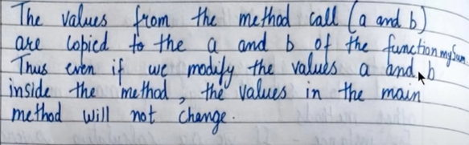

**Void return type:**

When we don’t want our method to return anything, we use void as the return type

package com.company;  
import java.util.Locale;  
import java.util.Scanner;  
  
public class Main {  
 static void GM(){  
 System.out.println("good morning");  
 }  
 public static void main(String[] args) {  
 *GM*();  
  
 }  
}

static method in a class is shared by all the objects

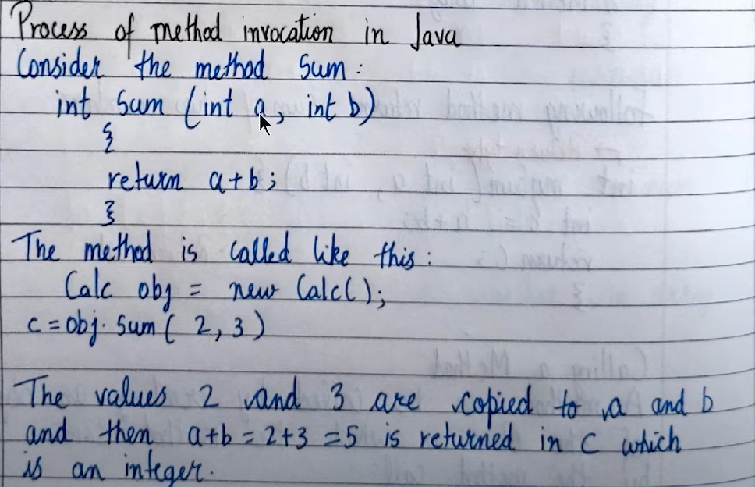

package com.company;  
import java.util.Locale;  
import java.util.Scanner;  
  
public class Main {  
 static void change(int a){  
 a = 98;  
 }  
 public static void main(String[] args) {  
 int[] marks = {23,45,32,15,65};  
 int x = 45;  
 *change*(x);  
 System.out.println("value of x after running change method is: " + x);  
  
 }  
}

output is 45

here a copy of x is passed to the method ‘change’ hence there will be no change in value of x

--------------------------------------------------------------------------------------------

package com.company;  
import java.util.Locale;  
import java.util.Scanner;  
  
public class Main {  
 static void change(int [] arr){  
 arr[0] = 98;  
 }  
 public static void main(String[] args) {  
 int[] marks = {23,45,32,15,65};  
 *change*(marks);  
 System.out.println("value of x after running change method is: " + marks[0]);  
  
 }  
}

here the output is 98

here marks store the address/reference of the array marks and when it is passed into the method the address/reference is passed so whatever changes we will do we will be making them in the original marks array.

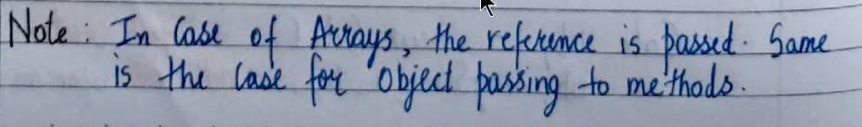

--------------------------------------------------------------------------------------------

Method overloading:

Two or more methods can have same name but different parameters. Such methods are called overloaded methods

Ex: void fool ()

Void fool (int a)

Int fool (int a, int b)

package com.company;  
import java.util.Locale;  
import java.util.Scanner;  
  
public class Main {  
 static void fool (){  
 System.out.println("good morning");  
 }  
 static void fool(int a){  
 System.out.println("the value of a is: "+a);  
 }  
 static int fool (int a,int b){  
 int c = a+b;  
 return c;  
 }  
 public static void main(String[] args) {  
 *fool*();  
 int x = 25;  
 int y = 24;  
 *fool*(x);  
 int z = *fool*(x,y);  
 System.out.println(z);  
  
  
  
  
 }  
}

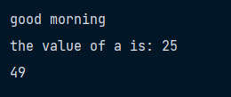

here ‘x’ and ‘y’ are **arguments** and ‘a’ and ‘b’ are **parameters.**

arguments are actual

**NOTE:**

*we cannot change the return type and define the same method again*

*ex: static void fool (int a, int b)*

*static int fool (int a, int b)*

***this will not work it will tell us there are 2 same functions, basically numbers of parameters should differ***

***method overloading is basically changing number of parameters. It cannot be performed by changing return type of methods***

variable arguments:

package com.company;  
import java.util.Locale;  
import java.util.Scanner;  
  
public class Main {  
 static int sum (int ... arr){  
 *// available as int[] arr* int result = 0;  
 for (int a:arr){  
 result+=a;  
 }  
 return result;  
 }  
  
 public static void main(String[] args) {  
 System.out.println("sum of2, 3, 4 and 5 is:" + *sum*(2,3,4,5));  
  
  
  
  
 }  
}

if no parameters are passed to the method sum output will be displayed as zero

package com.company;  
import java.util.Locale;  
import java.util.Scanner;  
  
public class Main {  
 static int sum (int x,int ... arr){  
 *// available as int[] arr* int result = x;  
 for (int a:arr){  
 result+=a;  
 }  
 return result;  
 }  
  
 public static void main(String[] args) {  
 System.out.println("sum of nothing is :" + *sum*(1));  
  
  
  
  
 }  
}

**recursions:**

package com.company;  
import java.util.Locale;  
import java.util.Scanner;  
  
public class Main {  
 static int factorial (int x){  
 if(x==1 || x==0){  
 return 1;  
 }  
 else{  
 return x\**factorial*(x-1);  
 }  
 }  
 public static void main(String[] args) {  
 int a = 5;  
 int ans = *factorial*(a);  
 System.out.println(ans);  
 }  
}

Fibonacci series:

package com.company;  
import java.util.Locale;  
import java.util.Scanner;  
  
public class Main {  
 static int fib (int x){  
 if (x==1||x==2) {  
 return x - 1;  
 }  
 else{  
 return *fib*(x-1)+*fib*(x-2);  
 }  
 }  
 public static void main(String[] args) {  
 int a = 5;  
 int ans = *fib*(a);  
 System.out.println(ans);  
 }  
}

Object oriented programming

DRY: do not repeat yourself

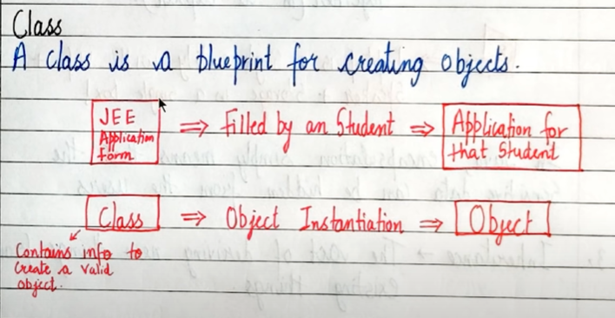

Object:

It is an instantiation of a class. Memory is allocated only after object instantiation

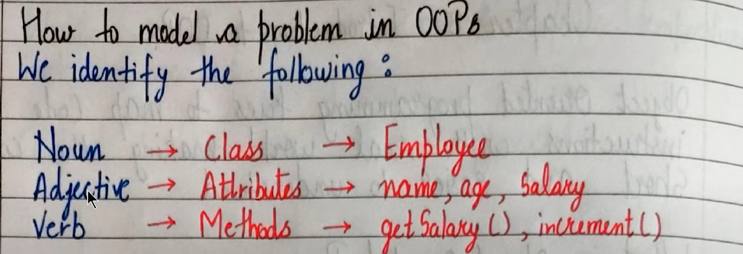

OOPS terminologies:

1. Abstraction:

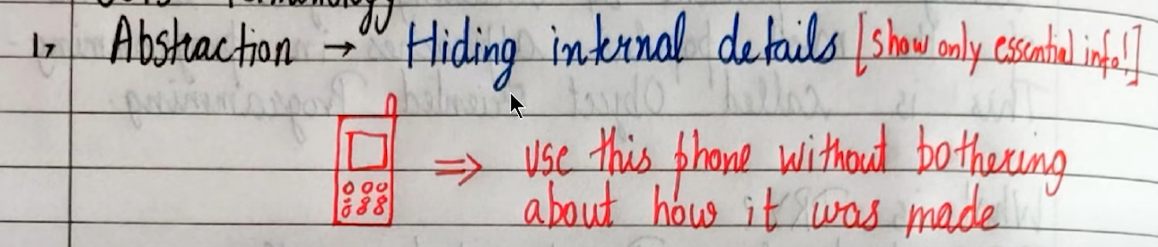Hiding internal details; shows us only essential info

1. Encapsulation:

The act of putting various components together (in a capsule).

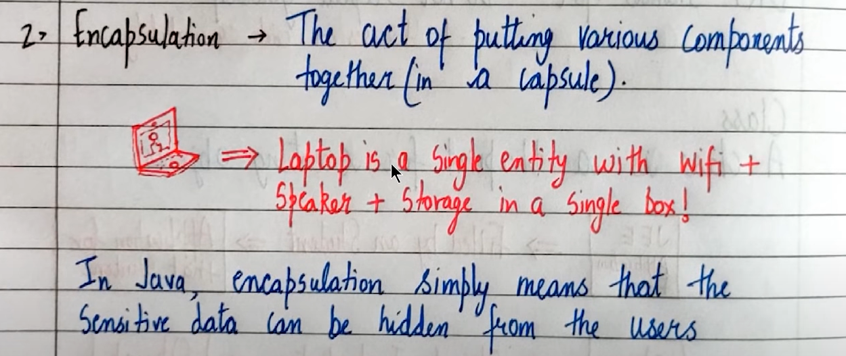In java encapsulation simply means that the sensitive data can be hidden from the users

1. Inheritance:

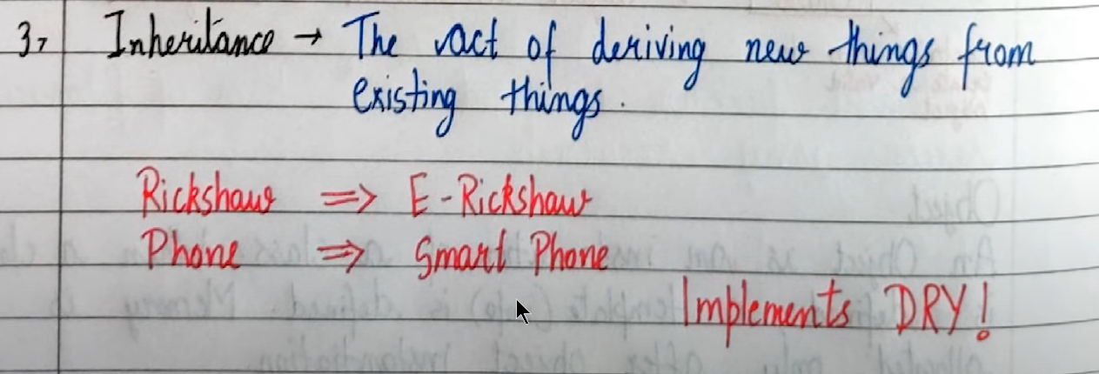The act of deriving new things from existing things

1. Polymorphism:

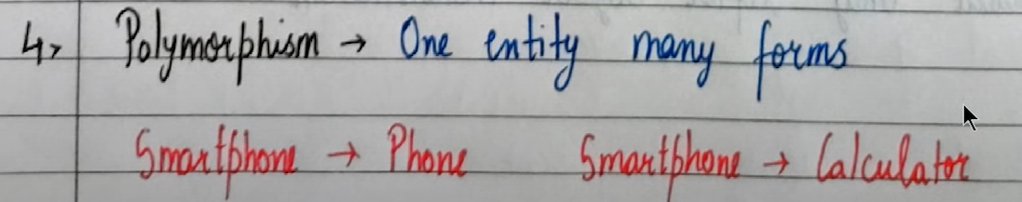One entity many forms

**Writing our custom class in Java**

There can be only one public class in a particular java file

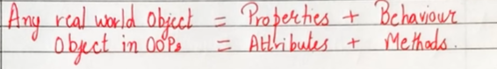

package com.company;

class Employee{  
 int id;  
 String name;  
 public void details(){  
 System.out.println("My id is "+ id);  
 System.out.println("My name is "+ name);  
 }  
}  
public class Main {  
 public static void main(String[] args) {  
 Employee abhi = new Employee(); *// Instantiating a new Employee object* abhi.id = 14;  
 abhi.name = "ABHISHEK";  
 System.out.println(abhi.id);  
 System.out.println(abhi.name);  
 abhi.details();  
 }  
}

CODES:

package com.company;  
import java.util.Locale;  
import java.util.Scanner;  
  
class Employee{  
 int salary;  
 String name;  
 public int getSalary(){  
 return salary;  
 }  
 public String getname(){  
 return name;  
 }  
 public String setname(String newname){  
 name = newname;  
 return name;  
 }  
  
}  
public class Main {  
 public static void main(String[] args) {  
 Employee abhi = new Employee(); *// Instantiating a new Employee object* abhi.salary = 140000;  
 abhi.name = "ABHISHEK";  
 System.out.println(abhi.getSalary());  
 System.out.println(abhi.getname());  
 System.out.println(abhi.setname("Abhishek"));  
  
 }  
}

Code to calculate perimeter and area of square using classes

package com.company;  
import java.util.Locale;  
import java.util.Scanner;  
  
class Shape{  
 int side;  
 public int side(){  
 return side;  
 }  
 public int peri(){  
 return 4*side;  
 }  
 public int area(){  
 return side*side;  
 }  
}  
public class Main {  
 public static void main(String[] args) {  
 Shape square = new Shape();  
 square.side = 5;  
 System.out.println(square.side());  
 System.out.println(square.peri());  
 System.out.println(square.area());  
 }  
}

**Access modifiers, getters and setters**

1. *Access modifiers:*

Specifier where a property/ method is accessible

4 types of access modifiers in java:

* *Private*
* *Default*
* *Protected*
* *Public*
* **Private:**

When using private access modifier we cannot directly write the statement abhi.name = “ABHISHEK” it will throw us an error. Hence we need to make getters and setters (methods).

Use of private access modifier is that we can impose certain restrictions on the type of input.

Ex: like when giving an input for a name int will not be allowed since in the set method only string parameters will be accepted.

package com.company;  
import java.util.Locale;  
import java.util.Scanner;  
  
class Employee{  
 private int id;  
 private String name;  
 public void setName(String n){  
 name = n;  
 }  
 public int getId(){  
 return id;  
 }  
 public String getName(){  
 return name;  
 }  
 public void setId(int i){  
 id = i;  
 }  
}  
  
public class Main {  
 public static void main(String[] args) {  
 Employee abhi = new Employee();  
 *//abhi.id = 12;  
 //abhi.name = "Abhishek"; --> throws an error due to private access modifier* abhi.setName("ABHISHEK");  
 abhi.setId(24);  
 System.out.println(abhi.getName());  
 System.out.println(abhi.getId());  
 }  
}

**Constructors in Java:**

It is a member function used to initialize an object while creating it

In order to write our own constructor, we define a method with same name as class name

--------------------------------------------------------------------------------------------here all the new objects will have the name as Abhishek and id as 45 until we change them.

If we do something like abhi.id = 19 and abhi.name = “Aj” then these will be the respective value for name and id

package com.company;  
import java.util.Locale;  
import java.util.Scanner;  
  
class Employee{  
 private int id;  
 private String name;  
 public Employee(){  
 id = 45;  
 name = "Abhishek";  
 }  
 public void setName(String n){  
 name = n;  
 }  
 public int getId(){  
 return id;  
 }  
 public String getName(){  
 return name;  
 }  
 public void setId(int i){  
 id = i;  
 }  
}  
  
public class Main {  
 public static void main(String[] args) {  
 Employee abhi = new Employee();  
 *//abhi.id = 12;  
 //abhi.name = "Abhishek"; --> throws an error due to private access modifier  
 //abhi.setName("ABHISHEK");  
 //abhi.setId(24);* System.out.println(abhi.getName());  
 System.out.println(abhi.getId());  
 }  
}

passing arguments to constructor

package com.company;  
import java.util.Locale;  
import java.util.Scanner;  
  
class Employee{  
 private int id;  
 private String name;  
 public Employee(String n, int p){  
 id = p;  
 name = n;  
 }  
 public void setName(String n){  
 name = n;  
 }  
 public int getId(){  
 return id;  
 }  
 public String getName(){  
 return name;  
 }  
 public void setId(int i){  
 id = i;  
 }  
}  
  
public class Main {  
 public static void main(String[] args) {  
 Employee abhi = new Employee("AJ",4);  
 *//abhi.id = 12;  
 //abhi.name = "Abhishek"; --> throws an error due to private access modifier  
 //abhi.setName("ABHISHEK");  
 //abhi.setId(24);* System.out.println(abhi.getName());  
 System.out.println(abhi.getId());  
 }  
}

constructor overloading can be done in same way as method overloading (means same class name but number of parameters differs)

package com.company;  
import java.util.Locale;  
import java.util.Scanner;  
  
class Employee{  
 private int id;  
 private String name;  
 public Employee (){  
 id = 45;  
 name = "Abhi";  
 }  
 public Employee(String n, int p){  
 id = p;  
 name = n;  
 }  
 public void setName(String n){  
 name = n;  
 }  
 public int getId(){  
 return id;  
 }  
 public String getName(){  
 return name;  
 }  
 public void setId(int i){  
 id = i;  
 }  
}  
  
public class Main {  
 public static void main(String[] args) {  
 Employee abhi = new Employee("AJ",4);  
 *//abhi.id = 12;  
 //abhi.name = "Abhishek"; --> throws an error due to private access modifier  
 //abhi.setName("ABHISHEK");  
 //abhi.setId(24);* System.out.println(abhi.getName());  
 System.out.println(abhi.getId());  
 }  
}

to make getter and setter methods automatically use ALT+INSERT

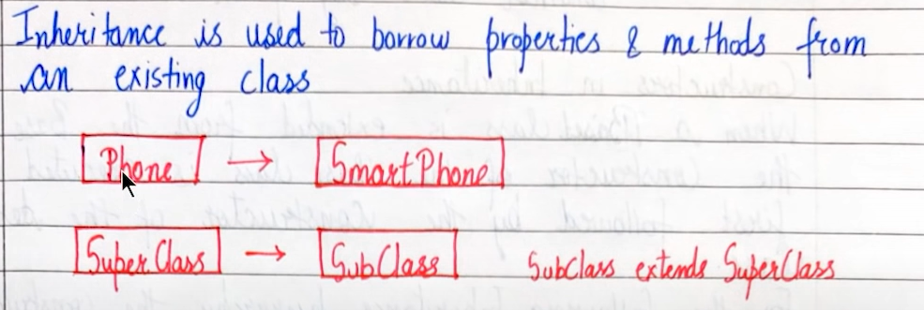**INHERITANCE:**

Parent is called super class/ base class/ parent class while child is called sub class

package com.company;  
import java.util.Locale;  
import java.util.Scanner;  
  
class base{  
 int x;  
 public int getx() {  
 return x;  
 }  
 public void setx(int x) {  
 this.x = x;  
 }  
 public void printme(){  
 System.out.println("I am a constructor");  
 }  
}  
class derived extends base{ *// example of inheritance* int y;  
 public int gety() {  
 return y;  
 }  
 public void sety(int y) {  
 this.y = y;  
 }  
}  
public class Main {  
 public static void main(String[] args) {  
 base b = new base();  
 b.setx(24);  
 System.out.println(b.getx());  
 derived a = new derived();  
 a.setx(25);  
 System.out.println(a.getx());  
 a.sety(26);  
 System.out.println(a.gety());  
 }  
}

***Java does not support multiple inheritance that is 2 classes cannot be superclasses for a subclass***

When a class inherits from a superclass, it inherits parts of superclass methods and fields that is it all depends on access modifiers.

THIS IS NOT ALLOWED IN JAVA

SUPERCLASS

SUPERCLASS

SUB CLASS

**Constructors in Inheritance:**

If a constructor is not made in derived class then it will access the constructor from the base class; and if it is there then it will access both base class constructor (first) as well as derived class constructor (next)

package com.company;  
import java.util.Locale;  
import java.util.Scanner;  
  
class base{  
 base(){  
 System.out.println("I am a constructor");  
 }  
}  
class derived extends base { *// example of inheritance* int y;  
  
 derived() {  
 System.out.println("I am a derived constructor");  
 }  
}  
public class Main {  
 public static void main(String[] args) {  
 base b = new base();  
 derived d = new derived();  
 }  
}

if there are 2 constructors in the parent class then the one with no parameter will be executed by default

but now suppose we want to call the constructor with parameter then we will use the keyword **“super”**

package com.company;  
import java.util.Locale;  
import java.util.Scanner;  
  
class base{  
 base(){  
 System.out.println("I am a constructor");  
 }  
 base (int a){  
 System.out.println("I am overloaded constructor with parameter a as: "+ a);  
 }  
}  
class derived extends base { *// example of inheritance* int y;  
  
 derived() {  
 super(0);  
 System.out.println("I am a derived constructor");  
 }  
}  
public class Main {  
 public static void main(String[] args) {  
 base b = new base();  
 derived d = new derived();  
 }  
}

now overloading derived constructor

package com.company;  
import java.util.Locale;  
import java.util.Scanner;  
  
class base{  
 base(){  
 System.out.println("I am a constructor");  
 }  
 base (int a){  
 System.out.println("I am overloaded constructor with parameter a as: "+ a);  
 }  
}  
class derived extends base { *// example of inheritance* int y;  
  
 derived() {  
 super(0);  
 System.out.println("I am a derived constructor");  
 }  
 derived(int x, int y){  
 super(0);  
 System.out.println("the value of y is: "+ y);  
 }  
}  
public class Main {  
 public static void main(String[] args) {  
 base b = new base();  
 derived d = new derived(14,9);  
 }  
}

**this keyword:**

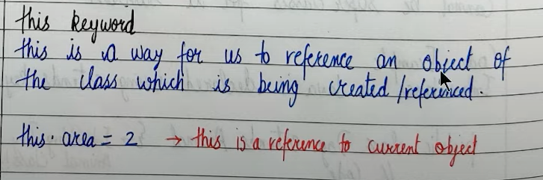this.**a** = a means 🡪 iss object ka **a** ka value is ‘a’(this ‘a’ can be any data type)

**super keyword:**

a reference variable used to refer immediate parent class object

* Can be used to refer immediate parent class instance variable
* Can be used to invoke parent class methods
* Can be used to invoke parent class constructors

**Method overriding**

package com.company;  
import java.util.Locale;  
import java.util.Scanner;  
  
class base{  
 public void method1(){  
 System.out.println("method 1 of base");  
 }  
}  
class derived extends base { *// example of inheritance* @Override  
 public void method1(){  
 System.out.println("method 2 of base");  
 }  
}  
public class Main {  
 public static void main(String[] args) {  
 base b = new base();  
 derived d = new derived();  
 d.method1();  
 }  
}

Output: method 2 of base

The following code is not an example of method overriding

package com.company;  
import java.util.Locale;  
import java.util.Scanner;  
  
class base{  
 public void method1(int a){  
 System.out.println("method 1 of base");  
 }  
}  
class derived extends base { *// example of inheritance* public void method1(){  
 System.out.println("method 2 of base");  
 }  
}  
public class Main {  
 public static void main(String[] args) {  
 base b = new base();  
 derived d = new derived();  
 d.method1();  
 }  
}

@Override annotation is recommended to write so that it will help us to check which methods are we actually overriding like in the above code we cannot use @Override it will give us an error since no of parameters are different in method1 of base class and of derived class. Even if we change access modifier from public to private it is not method overriding

**Dynamic method dispatch**

package com.company;  
import java.util.Locale;  
import java.util.Scanner;  
  
class Phone{  
 public void name(){  
 System.out.println("I am a phone");  
 }  
 public void greet(){  
 System.out.println("welcome user!");  
 }  
}  
class Smartphone extends Phone { *// example of inheritance* public void name(){  
 System.out.println("I am a smartphone");  
 }  
 public void swagat(){  
 System.out.println("Swagat nahi karoge humara");  
 }  
}  
public class Main {  
 public static void main(String[] args) {  
 Phone obj = new Smartphone();*// called runtime polymorphism because at runtime the object is created  
 // we can do this if on LHS we have parent class and on RHS we have child class* obj.greet();  
 obj.name(); *// this is called dynamic method dispatch* obj.swagat(); *// not allowed* }  
}

output:

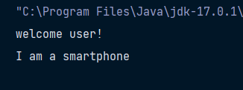

**Abstract class and abstract methods:**

Abstract method: a method that is declared without an implementation

Abstract class: if a class includes abstract methods, then the class itself must be declared as abstract

package com.company;  
import java.util.Locale;  
import java.util.Scanner;  
  
abstract class base{  
 public base() {  
 System.out.println("I am a constructor of base");  
 }  
 public void sayhello(){  
 System.out.println("Hello");  
 }  
 abstract public void greet();  
}  
class derived extends base{  
 @Override  
 public void greet(){  
 System.out.println("Good morning");  
 }  
}  
*// in order to be a valid class derived2 either declare it as abstract or override abstract method*abstract class derived2 extends base{  
 public void print(){  
 System.out.println("HELLO USER");  
 }  
}  
public class Main {  
 public static void main(String[] args) {  
 derived d = new derived();  
 d.greet();  
  
 }  
}

now remember since base class is an abstract class its object cannot be created that is we cannot write **base b = new base()**

hence abstract classes cannot have an object

when an abstract class is subclassed, the subclass usually provides implementations for all of the methods in parent class. If it doesn’t it must be declared abstract

**INTERFACES:**

Interfaces is a point where 2 systems meet and interact

In java interface is a group of related methods with empty bodies

Interfaces objects cannot be made. Keyword “implements” is used.

In abstract class there can be some non abstract methods but in interfaces all the methods are abstract

If we are using interfaces then when defining a proper class we will need to redefine all the abstract methods in the class compulsorily.

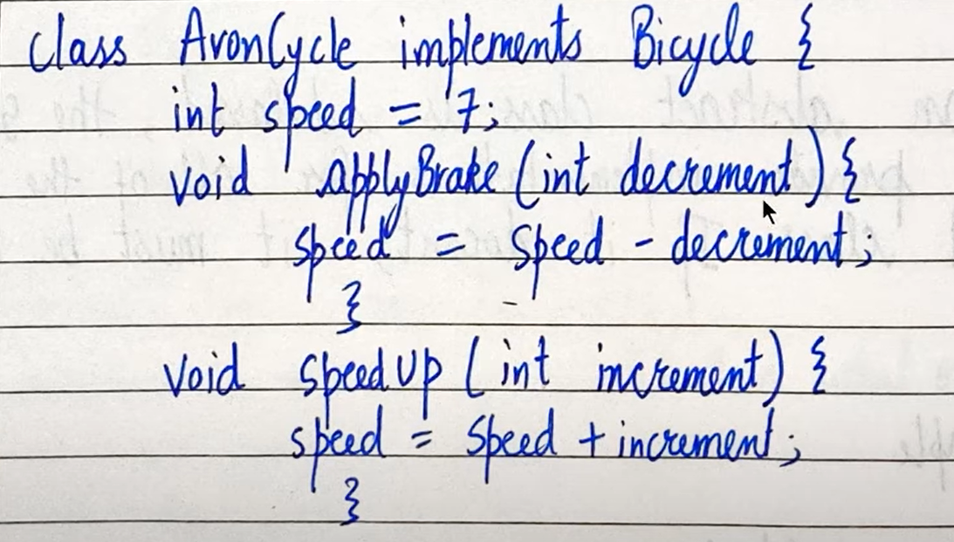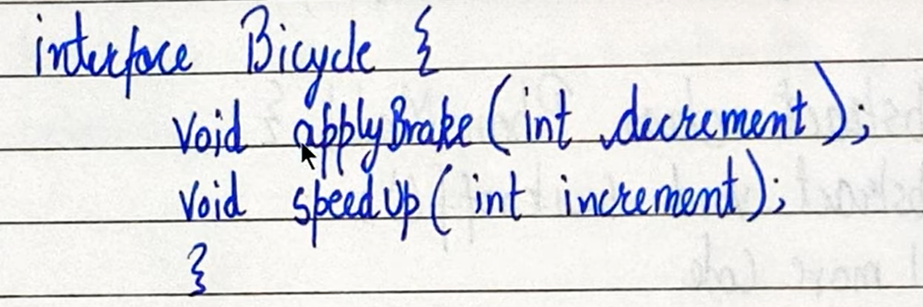EXAMPLE:

When we are redefining methods of interface in a proper class then make sure to make them **public; they are public by default**

package com.company;  
import java.util.Locale;  
import java.util.Scanner;  
  
interface *Bicycle*{  
 int a = 45;  
 void applybrake(int dec);  
 void speedup(int inc);  
}  
*// declare herocycle class as abstract or write all the methods in interface Bicycle in class herocycle*class herocycle implements *Bicycle*{  
 *// now when we are defining implement method WE WILL HAVE TO MAKE THEM PUBLIC* public void applybrake(int dec){  
 System.out.println("apply brakes");  
 }  
 public void speedup(int inc){  
 System.out.println("accelerating");  
 }  
}  
public class Main {  
 public static void main(String[] args) {  
 herocycle c1 = new herocycle();  
 c1.applybrake(21);  
 System.out.println(c1.a); *// will return 45* System.out.println(*Bicycle*.a); *// will return 45  
 // we cannot modify the properties in interface that is  
 // we cannot do Bicycle.a = 45 will throw us an error  
 // and c1.a = 34 will show us an error too* }  
}

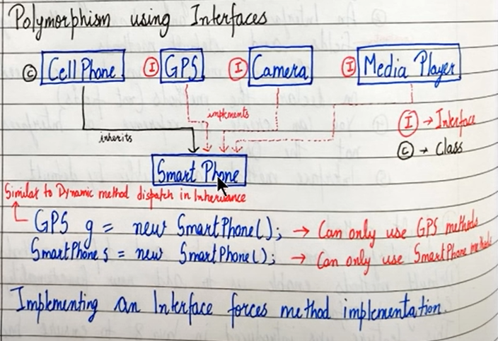multiple inheritance is not allowed in java but can be achieved using interfaces

Example:

package com.company;  
import org.w3c.dom.ls.*LSOutput*;  
  
import java.util.Locale;  
import java.util.Scanner;  
  
interface *Camera*{  
 void takesnap();  
 private void greet(){ *// we cannot use this method directly as it has private as access modifier* System.out.println("HELLO");  
 }  
 default void recordvideo(){ *// we can override this later in our class* greet();  
 System.out.println("Started recording video");  
 }  
}  
interface *wifi*{  
 String[] getnetworks();  
 void connecttonetwork(String network);  
}  
  
class phone{  
 void callnumber(int phoneno){  
 System.out.println("Dialing the number"+ phoneno);  
 }  
}  
  
class smartphone extends phone implements *wifi*, *Camera*{  
 public void takesnap(){  
 System.out.println("taking picture");  
 }  
 public String[] getnetworks(){  
 String[] networklist = {"airtel", "jio", "bsnl"};  
 return networklist;  
 }  
 public void connecttonetwork (String network){  
 System.out.println("\nConnecting...."+ network);  
 }  
}  
public class Main {  
 public static void main(String[] args) {  
 smartphone s = new smartphone();  
 s.takesnap();  
 String[] array = s.getnetworks();  
 for(String item:array){  
 System.out.printf(item + " ");  
 }  
 s.connecttonetwork("VODAFONE");  
 s.recordvideo();  
 *//s.greet();-- will throw us an error* }  
}

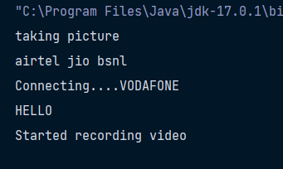

**Default methods**

* An interface can have static and default methods
* Default method enables us to add new functionality to existing interfaces
* Classes implementing the interface need not implement the default methods
* Interfaces can also include private methods for default methods to use

**Inheritance in interface**

package com.company;  
import org.w3c.dom.ls.*LSOutput*;  
  
import java.util.Locale;  
import java.util.Scanner;  
  
interface *parent* {  
 void meth1();  
 void meth2();  
}  
interface *child* extends *parent* {  
 void meth3();  
 void meth4();  
}  
class myclass implements *child*{  
 public void meth3(){  
 System.out.println("meth 3");  
 }  
 public void meth4(){  
 System.out.println("meth 4");  
 }  
 public void meth2(){  
 System.out.println("meth 2");  
 }  
 public void meth1(){  
 System.out.println("meth 1");  
 }  
}  
  
public class Main {  
 public static void main(String[] args) {  
 myclass m =new myclass();  
 m.meth1();  
 m.meth3();  
 }  
}

remember that interfaces cannot implement another interface, only classes can do that

**polymorphism in interfaces**

implementing an interface forces method implementation

package com.company;  
import java.util.Locale;  
import java.util.Scanner;  
  
interface *Camera*{  
 void takesnap();  
 private void greet(){ *// we cannot use this method directly as it has private as access modifier* System.out.println("HELLO");  
 }  
 default void recordvideo(){ *// we can override this later in our class* greet();  
 System.out.println("Started recording video");  
 }  
}  
  
interface *wifi*{  
 String[] getnetworks();  
 void connecttonetwork(String network);  
}  
  
class phone{  
 void callnumber(int phoneno){  
 System.out.println("Dialing the number"+ phoneno);  
 }  
}  
  
class smartphone extends phone implements *wifi*, *Camera*{  
 public void takesnap(){  
 System.out.println("taking picture");  
 }  
 public String[] getnetworks(){  
 String[] networklist = {"airtel", "jio", "bsnl"};  
 return networklist;  
 }  
 public void connecttonetwork (String network){  
 System.out.println("\nConnecting...."+ network);  
 }  
}  
public class Main {  
 public static void main(String[] args) {  
 *Camera* c = new smartphone();*// it is a smartphone but pls use it as a camera* c.takesnap(); *// we can only use methods of camera for object c* c.recordvideo();  
 *//c.getnetworks(); -- will throw us an error since we have created an object of camera from smartphone* }  
}

NOTE:

subClass c = new Class()

Here subclass is a reference and Class is an object and it is read as

Reference c is a new class object

**Interpreter vs compiler**

|  |  |
| --- | --- |
| **INTERPRETER** | **COMPILER** |
| 1. Translates one statement at a time into machine code | Scans the entire program and translates whole of it into machine code |
| 1. Interpreter is needed every time | Once complied it is not needed |
| 1. Partial execution if error | no execution if an error occurs |
| 1. Easy for programmers | Usually not as easy as interpreted ones |

Compiler runs faster than interpreter

Java is a hybrid language both interpreted as well as compiled

**PACKAGES:**

A package is used to group related classes

Packages help in avoiding name conflicts

2 types of packages:

* Built in: Java API
* User defined packages: custom packages

**Creating Packages:**

* Import java.lang* 🡪 imports everything from java.lang
* Import java.lang.String 🡪 import String from java.lang
* S = new Java.long.String(“Harry) 🡪 use without importing

Javac Harry.java – Creates Harry class

Javac -d.Harry.java – creates a package folder (We can keep adding classes to a package like this)

We can also create inner packages by adding “package.inner” as package name .Here package is folder and inner is subfolder.

These packages once used can be created by other classes

Javac-d.*.java – will move all java files into corresponding package

**ACCESS MODIFIERS:**

Access modifiers determine whether other classes can use a particular field or invoke a particular method.

* PUBLIC
* PRIVATE
* PROTECTED
* 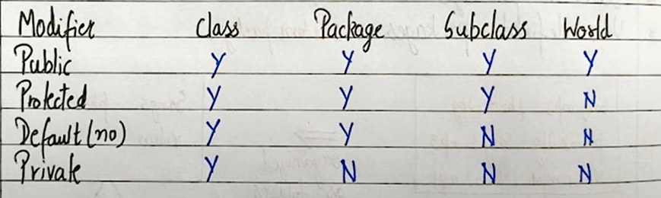DEFAULT (NO MODIFIER)

Subclass – means class of another package

World means which does not fall under class or package or subclass (another package ke main method mein)

package com.company;  
import java.util.Locale;  
import java.util.Scanner;  
  
class c1{  
 public int x = 12;  
 private int y = 14;  
 protected int z = 15;  
 int w = 20;  
 *// using x,y,z,w in same class* public void meth1(){  
 System.out.println(x);  
 System.out.println(y);  
 System.out.println(z);  
 System.out.println(w);  
 }  
}  
  
public class Main {  
 public static void main(String[] args) {  
 c1 c = new c1();  
 c.meth1();  
 *// using x,y,z,w in same package* System.out.println(c.x);  
 *//System.out.println(c.y); private will throw an error* System.out.println(c.z);  
 System.out.println(c.w);  
 }  
}

**MULTITHREADING IN JAVA:**

Multiprocessing and multithreading both are used to achieve multitasking

Threads use shared memory area

In threads faster context switching is possible

A thread is light weight whereas a process is heavyweight

EXAMPLE: A word processor can have one thread running in foreground as an editor and another in the background for auto saving the document

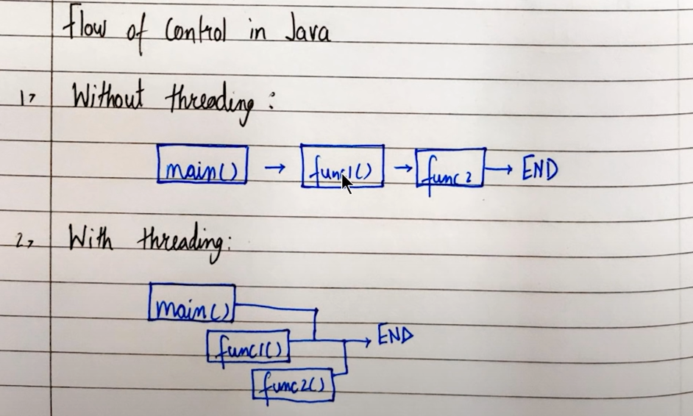FLOW OF CONTROL IN JAVA:

There are 2 ways to create a thread in java:

1. By extending thread class
2. By implementing runnable interface

***Concurrency is the task of running and managing multiple computations at the same time***

***While parallelism is the task of running and managing multiple computations simultaneously***

package com.company;  
import java.util.Locale;  
import java.util.Scanner;  
  
class mythread1 extends Thread{  
 @Override  
 public void run(){  
 int i = 0;  
 while (i<4000) {  
 System.out.println("My thread is running");  
 System.out.println("Thread is an inbuilt class");  
 i++;  
 }  
 }  
}  
class mythread2 extends Thread{  
 @Override  
 public void run(){  
 int i = 0;  
 while (i<4000) {  
 System.out.println("thread is running but a different one");  
 System.out.println("Thread is an inbuilt class again in this case");  
 i++;  
 }  
 }  
}  
  
public class Main {  
 public static void main(String[] args) {  
 mythread1 m1 = new mythread1();  
 mythread2 m2 = new mythread2();  
 m1.start();*// inbuilt function to run/start a thread* m2.start();  
 *// here for the output for some time it is showing output of mythread1 and for some time it is showing  
 // output of mythread2 and this is happening for an infinite loop* }  
}

*if we would have used m1.run in place of m1.start then for 4000 times consecutively we would have gotten mythread1 output and for the next 4000 times mythread2 output*

Thread is an inbuilt class

Runnable is an inbuilt interface

EXAMPLE:

Of runnable thread

package com.company;  
import java.util.Locale;  
import java.util.Scanner;  
  
class mythreadrunnable1 implements *Runnable* {  
 public void run() {  
 while(true){  
 System.out.println("I am a thread");  
 }  
 }  
}  
class mythreadrunnable2 implements *Runnable*{  
 public void run() {  
 while (true) {  
 System.out.println("Runnable is an inbuilt interface");  
 }  
 }  
}  
  
public class Main {  
 public static void main(String[] args) {  
 mythreadrunnable1 bullet1 = new mythreadrunnable1();  
 Thread gun1 = new Thread(bullet1);*// we have given a runnable to a thread* mythreadrunnable2 bullet2 = new mythreadrunnable2();  
 Thread gun2 = new Thread(bullet2);  
 gun1.start();*// inbuilt method to run/start a thread* gun2.start();  
 }  
}

**Life cycle of a thread:**

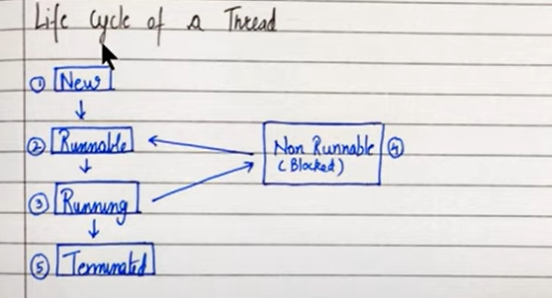

|  |  |
| --- | --- |
| **NEW** | Instance of thread created at which is not yet started by invoking start() |
| **RUNNABLE** | After invocation of start() and before it is scheduled to be run by the scheduler |
| **RUNNING** | After thread scheduler has selected it |
| **NON RUNNABLE** | Thread alive, not eligible to run |
| **TERMINATED** | Run() method has exited |

**Constructors from thread class in Java**

* Thread()
* Thread (String name)
* Thread (Runnable r)
* Thread (Runnable r, String name)

**THREAD PRIORITIES:**

package com.company;  
import java.util.Locale;  
import java.util.Scanner;  
  
class mythread1 extends Thread{  
 public mythread1 (String name){  
 super(name);  
 }  
 public void run(){  
 System.out.println("I am a thread "+ this.getName());  
 }  
}  
  
public class Main {  
 public static void main(String[] args) {  
 mythread1 m1 = new mythread1("ABHISHEK (most important)");  
 mythread1 m2 = new mythread1("ATISHAY (important)");  
 mythread1 m3 = new mythread1("ADITYA (normal)");  
 mythread1 m4 = new mythread1("AAGAM (average)");  
 mythread1 m5 = new mythread1("ATHARV (least)");  
 m1.setPriority(Thread.MAX_PRIORITY);  
 *// here it means that this ABHISHEK will be executed first  
 // when the same thing is written in an infinite loop we will see that Abihshek will be printed most number of times  
 // here abhihshek will always be first and atishay will always be last* m2.setPriority(Thread.MIN_PRIORITY);  
 m3.setPriority(Thread.NORM_PRIORITY);  
 m1.start();  
 m2.start();  
 m3.start();  
 m4.start();  
 m5.start();  
  
}  
}

**Java Thread Methods:**

package com.company;  
import java.util.Locale;  
import java.util.Scanner;  
  
class mythread1 extends Thread{  
 public mythread1 (String name){  
 super(name);  
 }  
 public void run(){  
 while(true){  
 System.out.println("I am a thread "+ this.getName());  
 }  
 }  
}  
  
public class Main {  
 public static void main(String[] args) {  
 mythread1 m1 = new mythread1("ABHISHEK");  
 mythread1 m2 = new mythread1("ATISHAY");  
 m1.start();  
 try{  
 m1.join(); *// we are using join if we want m2 to start only after m1 is done  
 // in an infinite loop only ABHISHEK will be printed* }  
 catch(Exception E){  
 System.out.println("ERROR");  
 }  
 m2.start();  
  
  
  
 }  
}

package com.company;  
import java.util.Locale;  
import java.util.Scanner;  
  
class mythread1 extends Thread{  
 public mythread1 (String name){  
 super(name);  
 }  
 public void run(){  
 while(true){  
 System.out.println("I am a thread "+ this.getName());  
 try {  
 Thread.*sleep*(455);*// I am a thread ABHISHEK will stop after 455 miliseconds* }  
 catch (InterruptedException e) {  
 e.printStackTrace();  
 }  
 }  
 }  
}  
  
public class Main {  
 public static void main(String[] args) {  
 mythread1 m1 = new mythread1("ABHISHEK");  
 mythread1 m2 = new mythread1("ATISHAY");  
 m1.start();  
 m2.start();  
 }  
}

package com.company;  
  
class Thread1 extends Thread{  
 public void run(){  
 System.out.println("Welcome");  
 }  
}  
class Thread2 extends Thread {  
 public void run() {  
 System.out.println("Good morning");  
 }  
}  
public class Main {  
 public static void main(String[] args) {  
 Thread1 t1= new Thread1();  
 Thread2 t2= new Thread2();  
 t1.start();  
 t2.start();  
 t1.setPriority(5);  
 t2.setPriority(1);  
  
 System.out.println(t1.getPriority());  
 System.out.println(t2.getPriority());  
 }  
}

getState() method is used to get the state of a given thread in Java

currentThread() method is used to reference the current thread in Java

package com.company;  
  
class Practice13 extends Thread{  
 public void run(){  
 while(true){  
 System.out.println("Good Morning!");  
 }  
 }  
}  
class Practice13b extends Thread{  
 public void run(){}  
}  
  
public class Main {  
 public static void main(String[] args) {  
 Practice13 p1 = new Practice13();  
 Practice13b p2 = new Practice13b();  
 *// p1.setPriority(6);  
 // p2.setPriority(9);* System.out.println(p1.getPriority());*// by default any thread priority is 5* System.out.println(p2.getPriority());  
 System.out.println(p2.getState()); *// the ans here will be new because p2.start() has not been made yet  
// p1.start();* p2.start();  
 System.out.println(p2.getState()); *// the ans will be runnable since p2.start() method has been declared* System.out.println(Thread.*currentThread*().getState());*// ans is runnable bcoz the thread has beeen started* }  
}

**ERRORS AND EXCEPTIONS IN JAVA**

There are 3 types of errors in JAVA

* Syntax Errors
* Logical Errors
* Runtime Errors (also called Exceptions)

Syntax errors: if variables are not declared and yet they are used it will give us syntax errors

Logical errors: a logical error or bug occurs when a program compiles and runs but does the wrong thing

Ex: 1. Message delivered wrongly, 2. Incorrect redirects

Runtime Errors: java may sometimes encounter an error while the program is running. They are also called exceptions. They are encountered due to circumstances like bad input or resource constraints

Ex: 1. User supplies “S” + 4 to a program which adds two numbers

Syntax errors and logical errors are encountered by the programmers whereas runtime errors are encountered by the users

**Exceptions in Java:**

An exception is an event that occurs when a program is executed disrupting the normal flow of instructions

There are mainly two types of exceptions in Java:

* Checked Exception – compile time exceptions (handled by compiler)
* Unchecked Exception – Runtime exceptions

Commonly occurring exceptions:

* Null pointer exception
* Arithmetic exception (divide by 0)
* Array index out of bound exception (going out of range for array)
* Illegal argument exception (if we want to pass String as an argument and we are passing int in place of it)
* Number format exception (if we want to convert a string number to int number)

TRY-CATCH BLOCK

package com.company;  
  
public class Main {  
 public static void main(String[] args) {  
 int a = 5000;  
 int b = 0;  
 try{  
 int c = a/b;  
 System.out.println("Result is "+c);  
 }  
 catch (Exception e){  
 System.out.println("We failed to divide, Reason: ");  
 System.out.println(e);  
 }  
 }  
}

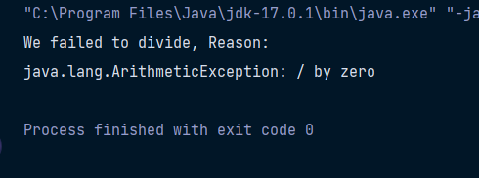

package com.company;  
import java.util.Scanner;  
  
public class Main {  
 public static void main(String[] args) {  
 int [] marks = new int[3];  
 marks[0] = 12;  
 marks[1] = 13;  
 marks[2] = 14;  
 Scanner sc = new Scanner(System.in);  
 System.out.println("Enter the array index: ");  
 int ind = sc.nextInt();  
 System.out.println("Enter the number you want to divide the value with: ");  
 int num = sc.nextInt();  
 try{  
 System.out.println("The value after performing the division operation is "+ marks[ind]/num);  
 }  
 catch (ArrayIndexOutOfBoundsException e){  
 System.out.println("Array Index Out Of Bounds Exception Occured");  
 }  
 catch (ArithmeticException e) {  
 System.out.println("Arithmetic Exception Occured");  
 }  
  
 }  
}

Nested try catch loops:

package com.company;  
  
import java.util.Scanner;  
  
public class cwh_82_nested_try_catch {  
 public static void main(String[] args) {  
 int [] marks = new int[3];  
 marks[0] = 7;  
 marks[1] = 56;  
 marks[2] = 6;  
 Scanner sc = new Scanner(System.in);  
 boolean flag = true;  
 while(flag) {  
 System.out.println("Enter the value of index");  
 int ind = sc.nextInt();  
 try {  
 System.out.println("Welcome to video no 82");  
 try {  
 System.out.println(marks[ind]);  
 flag = false;  
 } catch (ArrayIndexOutOfBoundsException e) {  
 System.out.println("Sorry this index does not exist");  
 System.out.println("Exception in level 2");  
 }  
 } catch (Exception e) {  
 System.out.println("Exception in level 1");  
 }  
 }  
 System.out.println("Thanks for using this program");  
 }  
}

**Exception class in Java**

The exception class has following important methods

* String toString() – executed when sout(e) is ran
* Void printStackTrace – prints Stack Trace
* String getMessage() – prints the exception message

**Throw keyword:**

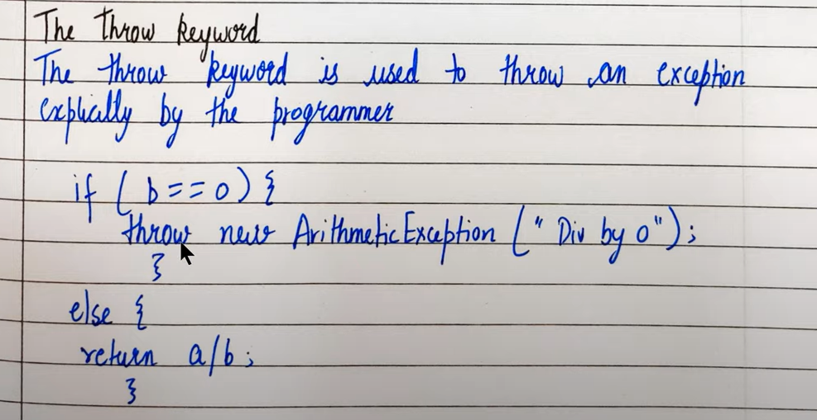The throw keyword is used to throw an exception explicitly by the programmer

In a similar manner we can throw user defined exceptions:

throw new MyException (“Exception thrown”)

**Throw vs Throws:**

package com.company;  
import java.util.Scanner;  
  
class Negativeradius extends Exception{  
 @Override  
 public String toString() {  
 return "Radius cannot be negative";  
 }  
  
 @Override  
 public String getMessage() {  
 return "Radius cannot be negative";  
 }  
}  
public class Main {  
 public static double area (int r) throws Negativeradius{  
 if (r<0){  
 throw new Negativeradius();  
 }  
 double result = Math.PI * r * r;  
 return result;  
 }  
  
 public static int divide(int a, int b) throws ArithmeticException {  
 int result = a / b;  
 return result;  
 }  
  
 public static void main(String[] args) {  
 try {  
 int c = *divide*(6, 0);  
 System.out.println(c);  
 double ar = *area*(6);  
 System.out.println(ar);  
 } catch (Exception e) {  
 System.out.println("Exception");  
 }  
 }  
}

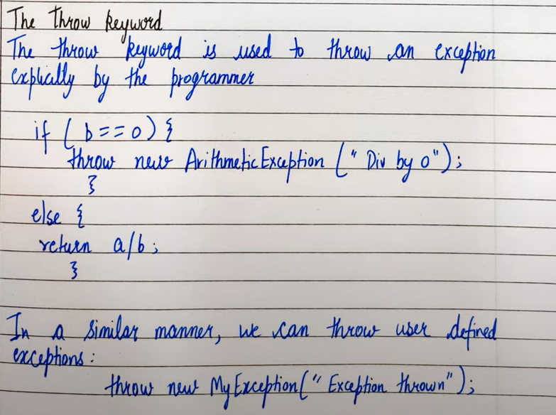

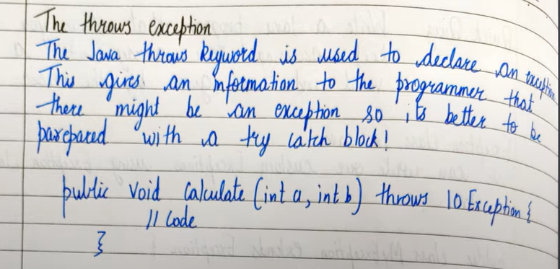Throws exception:

**Finally block in java**

Finally block contains the code which is always executed whether the exception is handled or not

package com.company;  
import java.util.Scanner;  
  
  
public class Main {  
 public static int greet(){  
 try {  
 int a = 5;  
 int b = 1;  
 int c = a / b;  
 return c; *// function will not stop here because it will see the finally block also* }  
 catch (Exception e) {  
 System.out.println(e);  
 }  
 finally {  
 System.out.println("this is the end of the program");  
 }  
 return 0;  
 }  
  
 public static void main(String[] args) {  
 *greet*();  
 int k = *greet*();  
 System.out.println(k);  
 int d = 5;  
 int e = 4;  
 while (true){  
 try{  
 System.out.println(d/e);  
 }  
 catch (Exception f){  
 System.out.println(f);  
 break;  
 }  
 *// here even after the loop is broken the final block will get executed* finally{  
 System.out.println("final value of e = "+e);  
 }  
 e--;  
 }  
 try{  
 System.out.println(5/0);  
 }  
 finally{  
 System.out.println("TRY - FINALLY block is also valid");  
 }  
 }  
}

***ADVANCED JAVA CONCEPTS:***

**java collections framework**

Collections framework:

A collection represents a group of object. Java collection provides Classes and interfaces for us to be able to write code quickly and efficiently

We need collections for efficient storage and better manipulation of data in Java

For ex: we use array to store int but what if we want to

* Resize this array
* Insert an element in between
* Delete an element in array
* Apply certain operations to change this array

Collections in Java are available as classes and interfaces

* ArrayList – for variable size collection
* Set – for distinct collection
* Stack – A LIFO data structure
* HashMap – for storing key value pairs

Collection class is available in java.util.package

Collection class also provides static methods for sorting, searching etc

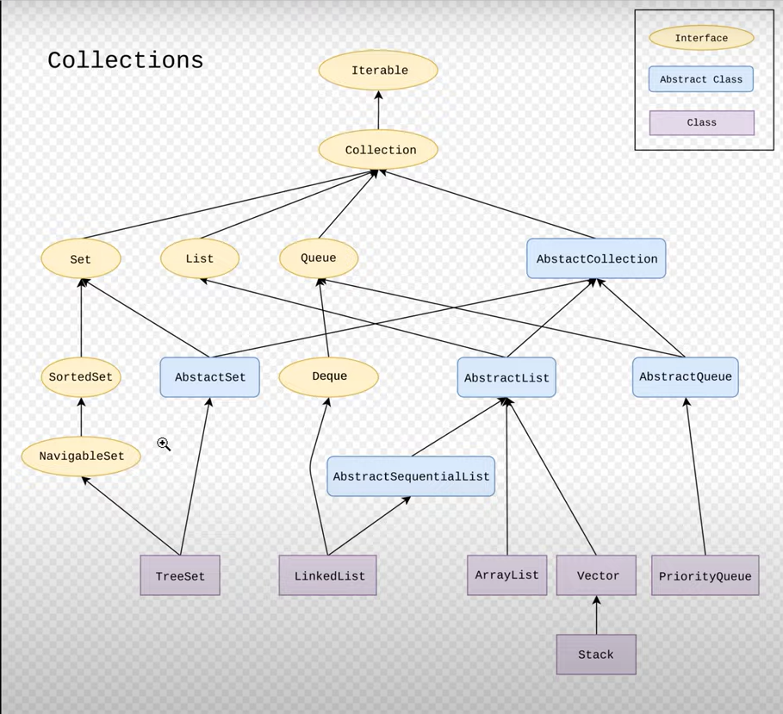**HIERARCHIAL STRUCTURE OF CLASSES**

package com.company;  
import java.util.ArrayList;  
import java.util.Scanner;  
import java.util.*Set*;  
import java.util.TreeSet;  
  
  
public class Main {  
 public static void main(String[] args) {  
 *//ArrayList  
 //Set  
 //TreeSet* }  
}

Just type ArrayList in main and press enter the import statement will automatically be printed

***TO VIEW DOCUMENTATION OF JAVA WRITE “JAVA 14 DOCS” ON YOUR BROWSER AND GO ON THE ORACLE ONE***

Import java.util.* 🡪 means import everything from java.util

ArrayList<Integer> l1 = new ArrayList<>();

* *Here the name of the array is l1 which will store integers in it but its size has not been defined*

package com.company;  
import java.util.*;  
  
  
public class Main {  
 public static void main(String[] args) {  
 ArrayList<Integer> l1 = new ArrayList<>();  
 ArrayList<Integer> l2 = new ArrayList<>(2);  
 l2.add(34); *// adds element to l2 from last* l2.add(24);  
 l1.add(6);  
 l1.add(4);  
 l1.add(6);  
 l1.add(0,5); *// adds 5 in l1 at index 0* l1.addAll(0,l2); *// used to add l2 in l1 from specific index  
 // if index is not mentioned then l2 will be added to l1 from the end of l1* for (int i=0 ; i<l1.size(); i++){  
 System.out.print(l1.get(i));  
 System.out.print(", ");  
 }  
 *//l1.clear();//empties the whole list* System.out.println();  
 System.out.println(l1.contains(5));*// returns bool if 5 is present in l1* System.out.println(l1.get(0)); *// returns value of index 0 in l1* System.out.println(l1.indexOf(23)); *// returns index of 6 in l1 or will give -1 if not found* System.out.println(l1.lastIndexOf(6)); *// returns index of 6 but here it is searching from the end of the list* System.out.println(l1.remove(0));*//removes value at index 0 in l1* l1.set(1,566); *// sets 566 at index 1 of l1* System.out.println(l1.get(1));  
  
  
 }  
}

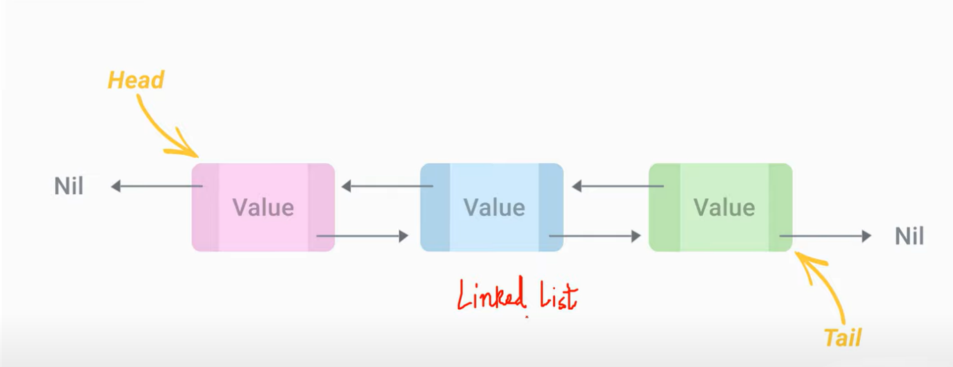**LINKED LIST**

We cannot predefine initial limit for linked list

Linked list and array methods are almost similar but their working is different

package com.company;  
import java.util.*;  
  
  
public class Main {  
 public static void main(String[] args) {  
 LinkedList<Integer> l1 = new LinkedList<>();  
 LinkedList<Integer> l2 = new LinkedList<>();  
 l2.add(34); *// adds element to l2 from last* l2.add(24);  
 l1.add(6);  
 l1.add(4);  
 l1.add(6);  
 l1.addFirst(2345);  
 l1.addLast(5454);  
 l1.add(0,5); *// adds 5 in l1 at index 0* l1.addAll(0,l2); *// used to add l2 in l1 from specific index  
 // if index is not mentioned then l2 will be added to l1 from the end of l1* for (int i=0 ; i<l1.size(); i++){  
 System.out.print(l1.get(i));  
 System.out.print(", ");  
 }  
 *//l1.clear();//empties the whole list* System.out.println();  
 System.out.println(l1.contains(5));*// returns bool if 5 is present in l1* System.out.println(l1.get(0)); *// returns value of index 0 in l1* System.out.println(l1.indexOf(23)); *// returns index of 6 in l1 or will give -1 if not found* System.out.println(l1.lastIndexOf(6)); *// returns index of 6 but here it is searching from the end of the list* System.out.println(l1.remove(0));*//removes value at index 0 in l1* l1.set(1,566); *// sets 566 at index 1 of l1* System.out.println(l1.get(1));  
  
  
 }  
}

**Deque:**

Double ended queue

package com.company;  
import java.util.*;  
  
  
public class Main {  
 public static void main(String[] args) {  
 ArrayDeque<Integer> ad1 = new ArrayDeque<>();*// initial capacity/size of deque is 16* ad1.add(16);  
 ad1.add(14);  
 System.out.println(ad1.getFirst());  
 System.out.println(ad1.getLast());  
 ad1.addFirst(11);  
 ad1.addLast(99);  
  
 }  
}

**HASHING TECHNIQUE**

Technique to convert key value pairs to indices

OPEN ADDRESSING:

Suppose the length of the array is 10 and our hashing function is f(x) = x%10. Now if we want to insert 14 to the array then it will be stored at 4th index (because 14%10 = 4) but suppose if we want to store 24 to the array then we cannot store it at the 4th index because that index is already filled (this is called as hash collision) so we move forward in the array until we find an empty space and store 24 over there

CLASSES/COLLECTIONS : HashSet, HashMap, LinkedHashMap, HashTable

CHAINING:

Now here we will say each empty space points to a linked list where similar type of elements will be stored. For example in the above case 4th index will point to a linked list where 14 and 24 will be stored

**HASHSET:**

Hashset has initial capacity of 16 and load factor of 0.75

Load factor should be float

package com.company;  
import java.util.*;  
  
  
public class Main {  
 public static void main(String[] args) {  
 *//In HashSet repetition is not allowed* HashSet<Integer> hs = new HashSet<>(6,0.5f);  
 hs.add(6);  
 hs.add(11);  
 hs.add(11);  
 hs.add(87);  
 System.out.println(hs); *// will not give an error, allowed for hashset, output will not be in the order in which  
 // u have inserted elements OP will be 11 6 87* }  
}

**DATE AND TIME IN JAVA:**

Date in Java is stored in the form of a long number (data type – long). This long number holds the number of milliseconds passed since 1 Jan 1970

Java assumes that 1900 is the start year which means it calculates years passed since 1900 whenever we ask it for years passed

System.currentTimeMillis() returns no of seconds passed. Once no of millisec are calculated we can calculate minutes, seconds and years passed

package com.company;  
import java.util.*;  
public class Main {  
 public static void main(String[] args) {  
 System.out.println(System.*currentTimeMillis*());  
 }  
}

**DATE CLASS IN JAVA**

package com.company;  
import java.util.*;  
public class Main {  
 public static void main(String[] args) {  
 System.out.println(Long.MAX_VALUE);  
 Date d = new Date();  
 System.out.println(d);  
 System.out.println(d.getTime()); *// tells time in milliseconds* }  
}

**CALENDAR CLASS IN JAVA:**

package com.company;  
import java.util.*;  
public class Main {  
 public static void main(String[] args) {  
 Calendar c = Calendar.*getInstance*();  
 System.out.println(c.getCalendarType()); *// output will be gregory (Gregorian Calendar)* System.out.println(c.getTimeZone());  
 Calendar d = Calendar.*getInstance*(TimeZone.*getTimeZone*("Asia/Singapore"));  
 System.out.println(d.getCalendarType()); *// output will be gregory (Gregorian Calendar)* System.out.println(d.getTimeZone().getID());*// will return Asia/Singapore // default is Asia/Calcutta* }  
}

package com.company;  
import java.util.*;  
public class Main {  
 public static void main(String[] args) {  
 Calendar c = Calendar.*getInstance*();  
 System.out.println(c.get(Calendar.MINUTE));  
 System.out.println(c.get(Calendar.MONTH));  
 System.out.println(c.get(Calendar.DATE));  
 System.out.println(c.get(Calendar.DAY_OF_WEEK));  
 System.out.println(c.get(Calendar.HOUR_OF_DAY));  
 GregorianCalendar cal = new GregorianCalendar();  
 System.out.println(cal.isLeapYear(2020));  
 System.out.println(TimeZone.*getAvailableIDs*(0));  
 System.out.println(TimeZone.*getDefault*());  
   
 }  
}

**JAVA TIME PACKAGE:**

LocalDate – represents a date

LocalTime – represents a time

LocalDateTime – represents Date + Time

DateTimeFormatter – Formatter for displaying and parsing date-time objects

package com.company;  
import java.time.LocalDate;  
import java.time.LocalDateTime;  
import java.time.LocalTime;  
import java.util.*;  
public class Main {  
 public static void main(String[] args) {  
 LocalDate d = LocalDate.*now*();  
 System.out.println(d); *// todays date will be printed* LocalTime t = LocalTime.*now*();  
 System.out.println(t); *// present time will be printed* LocalDateTime dt = LocalDateTime.*now*();  
 System.out.println(dt);  
 }  
}

package com.company;  
import java.time.LocalDate;  
import java.time.LocalDateTime;  
import java.time.LocalTime;  
import java.time.chrono.*ChronoLocalDate*;  
import java.time.format.DateTimeFormatter;  
import java.time.format.DateTimeFormatterBuilder;  
import java.util.*;  
public class Main {  
 public static void main(String[] args){  
  
 LocalDateTime dt = LocalDateTime.*now*(); *// this is the date* DateTimeFormatter dtf = DateTimeFormatter.*ofPattern*("dd-MM-yyyy--E H:m a"); *// this is the format  
 // E here means day of the week  
 // a means am,pm  
 // H means hour and m means minutes* String myDate = dt.format(dtf); *// creating date string using date and format* System.out.println(myDate);  
  
 DateTimeFormatter dtf2 = DateTimeFormatter.ISO_LOCAL_DATE;  
 String myDate2 = dt.format(dtf2);  
 System.out.println(myDate2);  
  
  
 }  
}

**Creating our own java docs for our package**

Java documentation helps us get info about which method/ class/ entity to use when

Go to tools and click on generate java docs

Tags for a class or package

@author : Adds the author name

@version : Adds the version

@Since : to add when was the version written

@See: Adds a sea also heading with a link

package com.company;  
*/**  
 * this class is to demonstrate use of java docs  
 \** ***@author*** *Abhishek  
 \** ***@version*** *0.1  
 \** ***@see*** *<a href = "https://www.youtube.com/watch?v=u7hFzG1n4mg&list=PLu0W_9lII9agS67Uits0UnJyrYiXhDS6q&index=106">Java Docs</a>  
 \** ***@since*** *2002  
*/*public class Main {  
 public static void main(String[] args){  
 System.out.println("WELCOME");  
 }  
}

**Annotations in Java:**

Used to provide extra information about a program

Annotations provide metadata to class/methods

**@Override:** used to mark overridden elements in the child class

**@SuppressWarnings:** used to suppress the generated warnings by the compiler

**@deprecated:** used to mark deprecated methods (the methods which are no longer in use or where in previous versions but not in the present version)

**@FunctionalInterface:** used to ensure an interface is functional interface

A functional interface is an interface that contains only a single abstract method

**LAMBDA EXPRESSIONS:**lambda expressions lets us express instances of single method classes more compactly

Anonymous classes are used to implement a base class without giving it a name

For classes with a single method, even anonymous classes get slightly excessive and cumbersome

ANONYMOUS CLASS

package com.company;  
interface *demo*{  
 void meth1();  
 void meth2();  
}  
public class Main {  
 public static void main(String[] args) {  
 *demo* obj = new demo() {  
 @Override  
 public void meth1() {  
 System.out.println("I am in meth 1");  
 }  
 @Override  
 public void meth2() {  
 System.out.println("I am in meth 2");  
 }  
 };  
 obj.meth1();  
 }  
}

Lambda expression

package com.company;  
interface *demo*{  
 void meth1(int a);  
}  
public class Main {  
 public static void main(String[] args) {  
 *demo* obj = (a)->{  
 System.out.println("I am in method 1 where a is: "+a);  
 };  
 obj.meth1(5);  
 }  
}

**JAVA GENERICS**

package com.company;  
import java.util.ArrayList;  
import java.util.Scanner;  
  
class generic <T1>{  
 int val;  
 private T1 t1;  
  
 public generic(int val,T1 t1) {  
 this.val = val;  
 this.t1 = t1;  
 }  
  
 public T1 getT1() {  
 return t1;  
 }  
  
 public void setT1(T1 t1) {  
 this.t1 = t1;  
 }  
  
 public int getVal() {  
 return val;  
 }  
  
 public void setVal(int val) {  
 this.val = val;  
 }  
}  
public class Main {  
 public static void main(String[] args) {  
 ArrayList al = new ArrayList();  
 al.add("a string");  
 al.add(23);  
 al.add(new Scanner(System.in));  
 int a = (int) al.get(1);  
 System.out.println(a);  
  
 ArrayList <Integer> al2 = new ArrayList<>();  
 al2.add(233);  
 al2.add(244);  
 int b = al2.get(0);  
 System.out.println(b);  
  
 generic<String> g = new generic(25,"abhi");  
  
 System.out.println(g.getVal());  
 String d = g.getT1();  
 System.out.println(d);  
 }  
}

**FILE HANDLING IN JAVA:**

package com.company;  
import java.io.File;  
import java.io.FileNotFoundException;  
import java.io.FileWriter;  
import java.io.IOException;  
import java.util.Scanner;  
  
public class Main {  
 public static void main(String[] args) {  
 *// Code to create a new file  
 /*File myfile = new File("ABHI.txt");  
 try {  
 myfile.createNewFile();  
 } catch (IOException e) {  
 System.out.println("Unable to create file");  
 e.printStackTrace();  
 }*/  
  
 //Code to write to a file* try {  
 FileWriter fw = new FileWriter("ABHI.txt");  
 fw.write("this is the first line\nOk now moving to second line");  
 fw.close();  
 }  
 catch (IOException e){  
 e.printStackTrace();  
 }  
  
 *//Reading a file* File mf = new File("ABHI.txt");  
 try {  
 Scanner sc = new Scanner(mf);  
 while(sc.hasNextLine()){  
 String l = sc.nextLine();  
 System.out.println(l);  
 }  
 sc.close();  
 }  
 catch(FileNotFoundException e){  
 e.printStackTrace();  
 }  
  
 *// Deleting a file* File f2 = new File("ABHI.txt");  
 if(f2.delete()){  
 System.out.println("I have deleted: "+ f2.getName());  
 }  
 else{  
 System.out.println("Some error occured while deleting the file");  
 }  
  
 }  
}